<https://dynamicpapers.com/wp-content/uploads/2015/09/9709_s25_qp_12.pdf>

(Questions 1,5,6,10,11)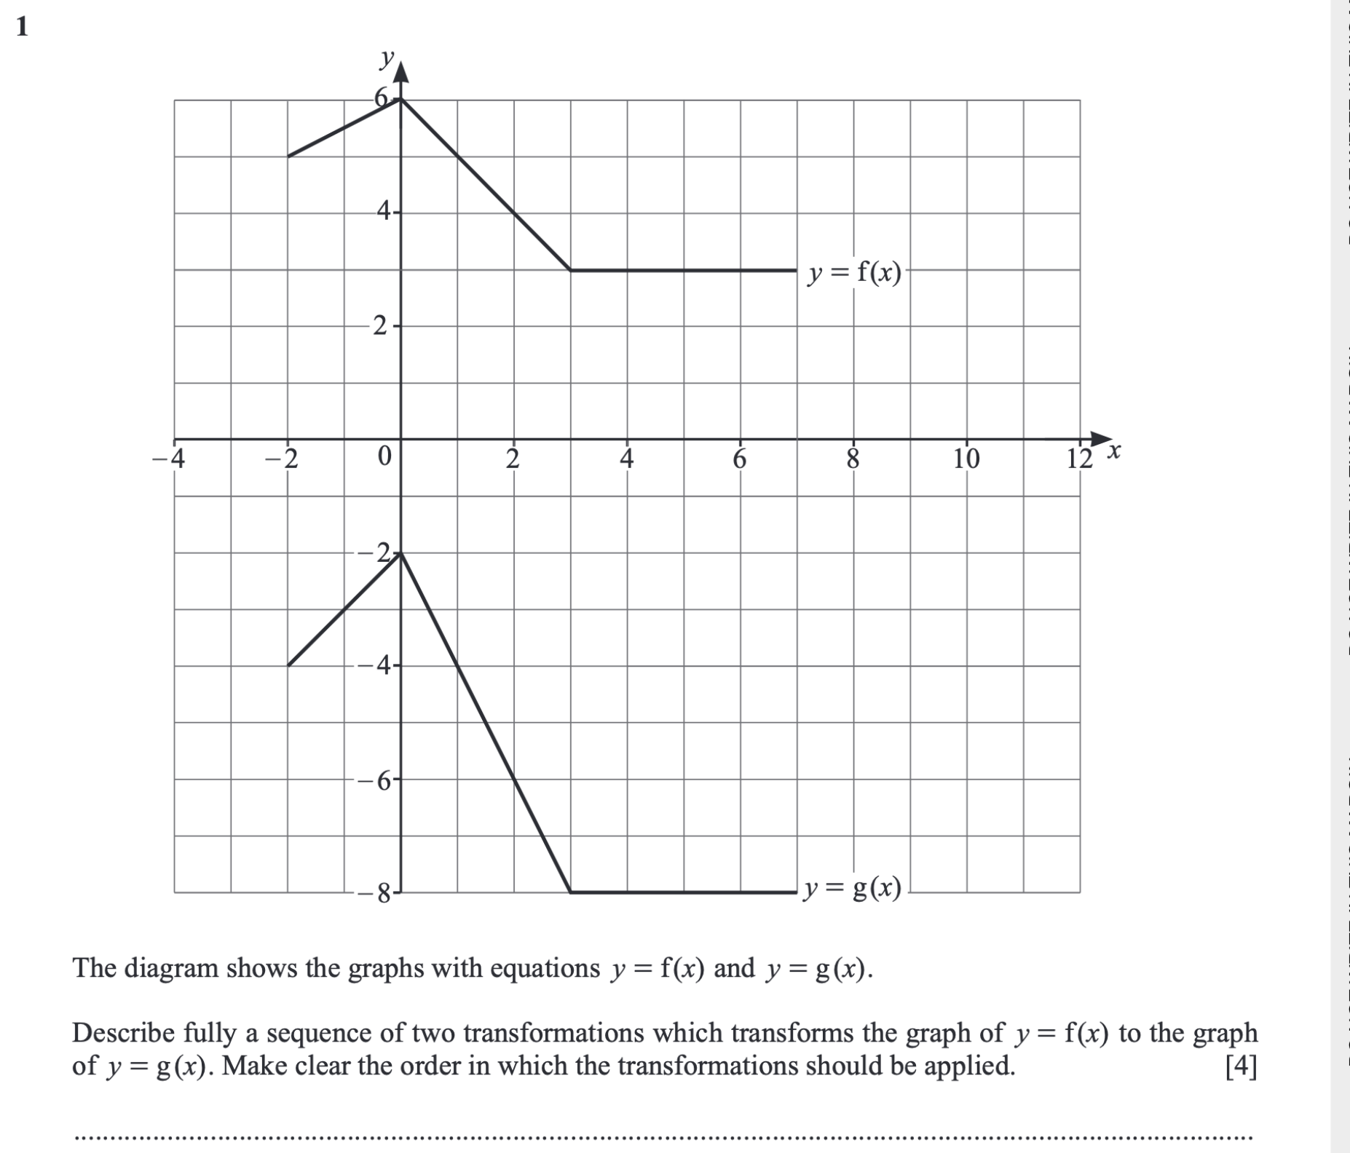

(

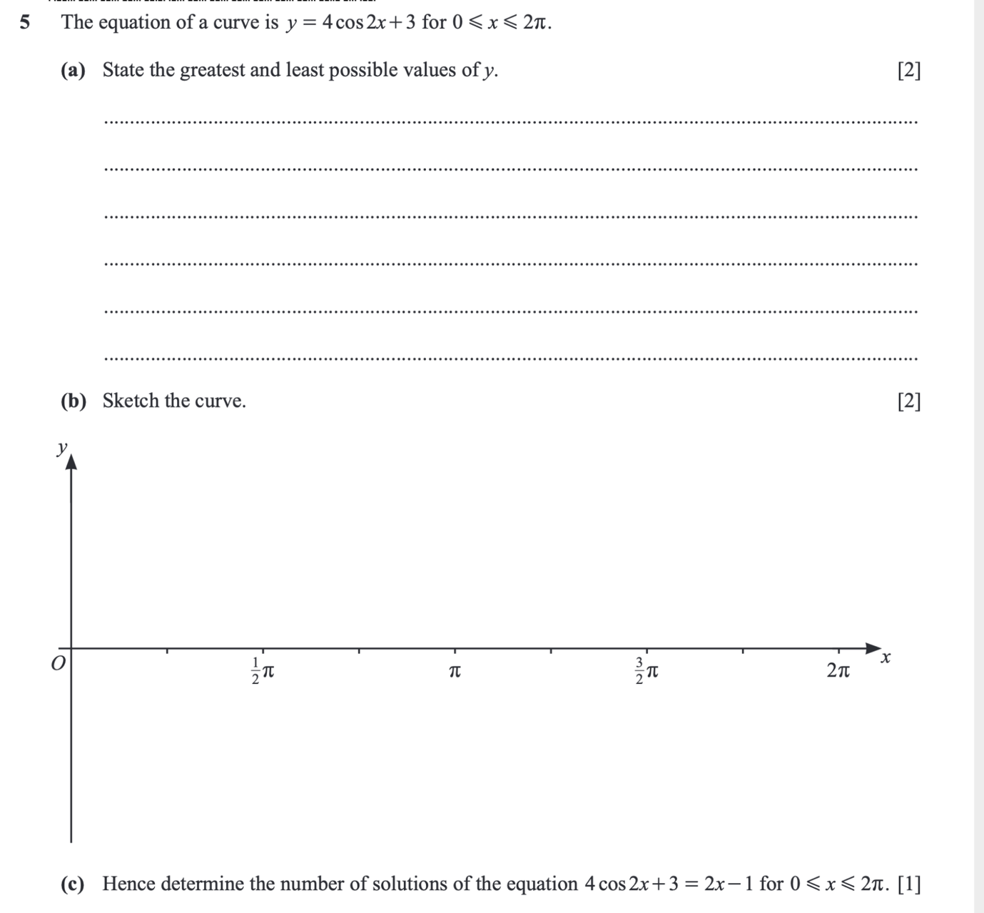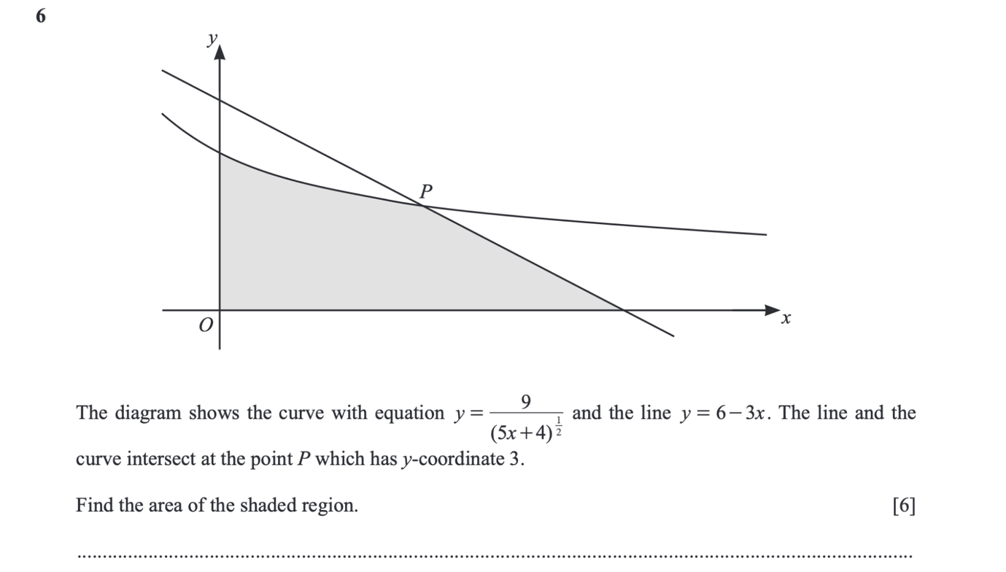

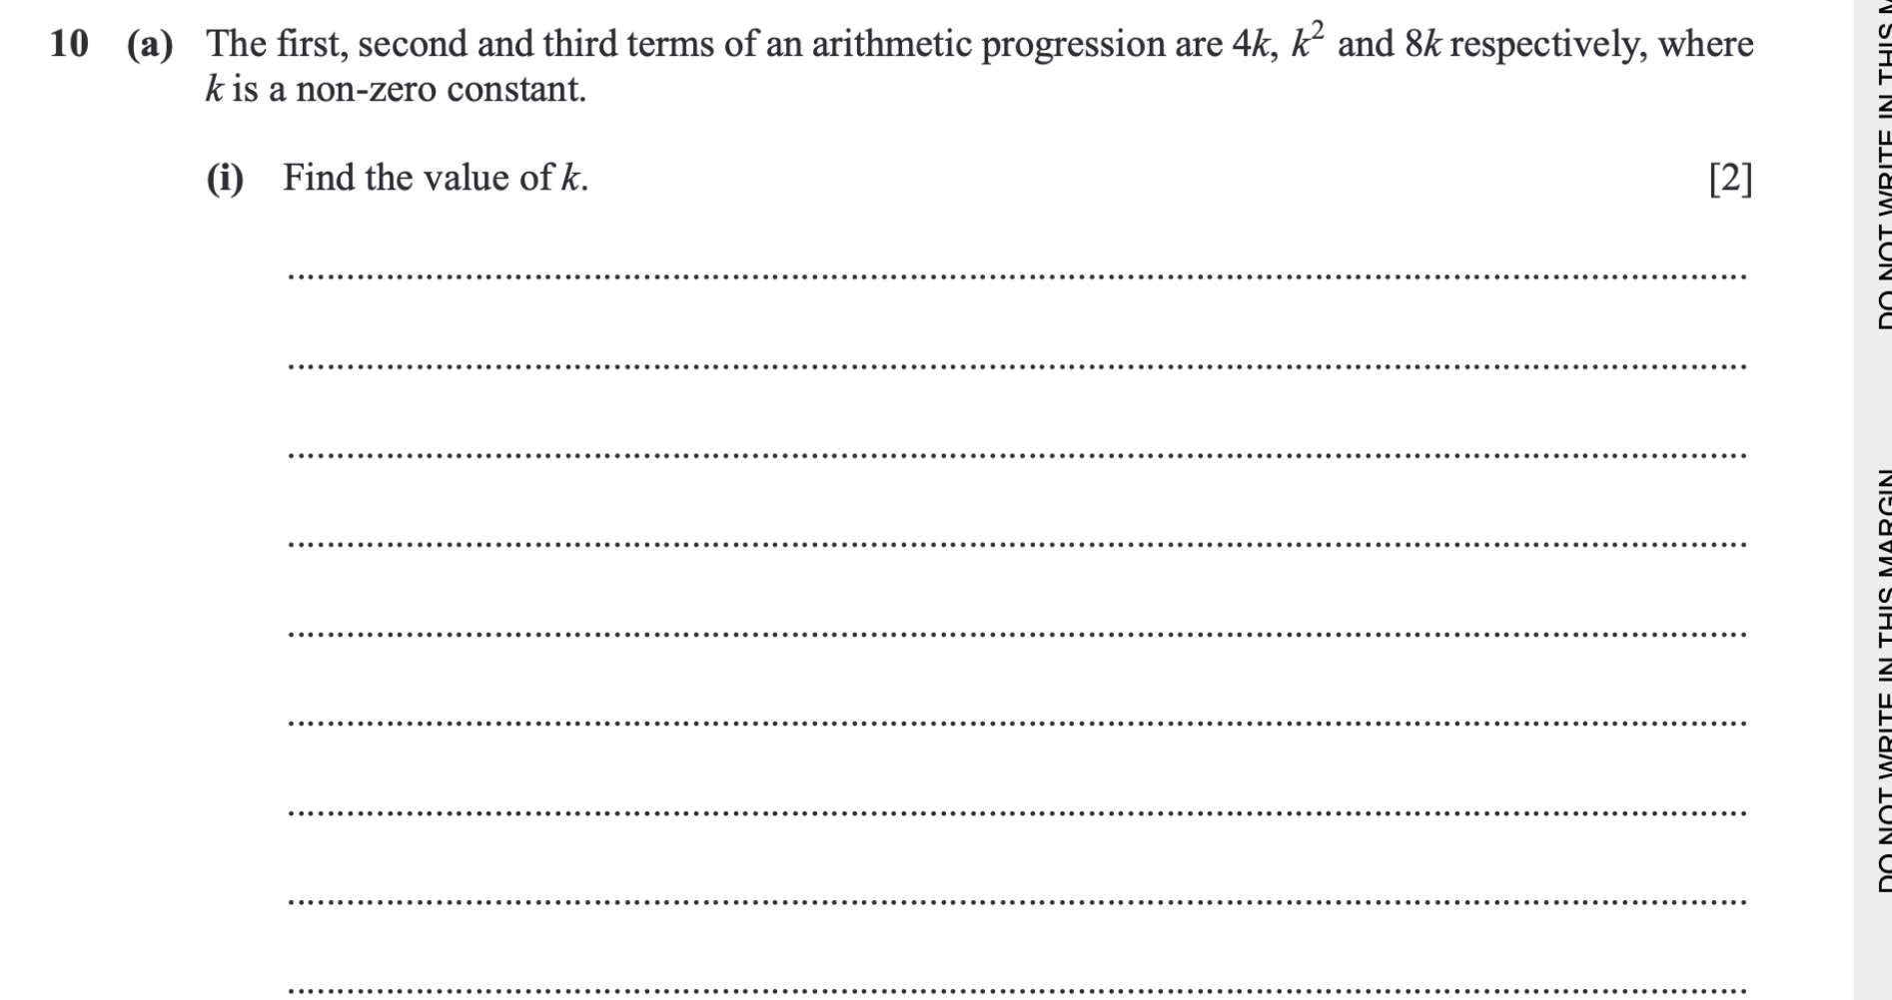

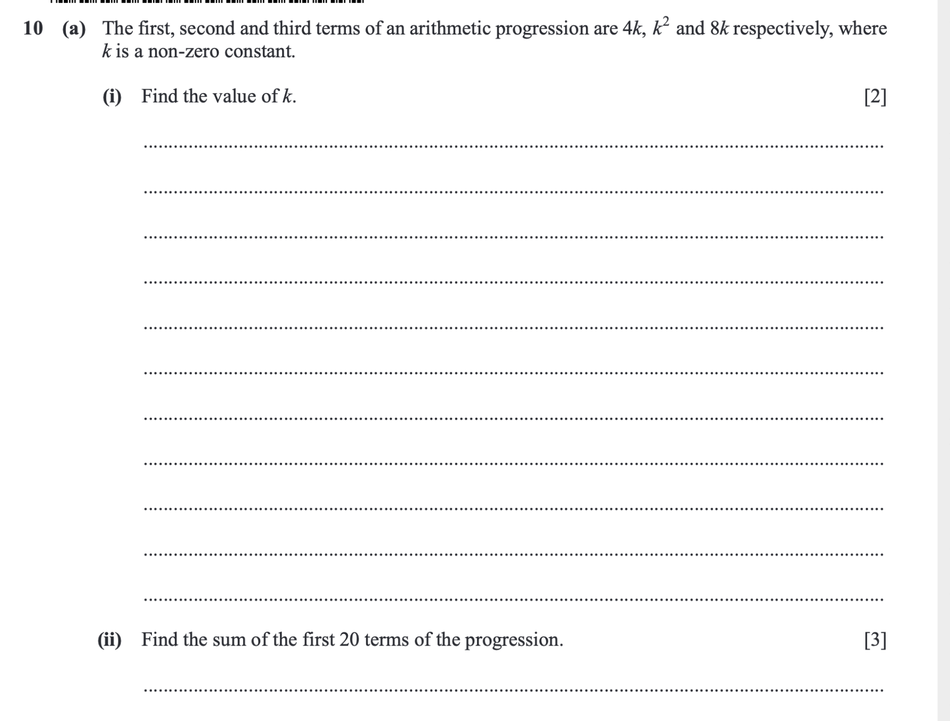

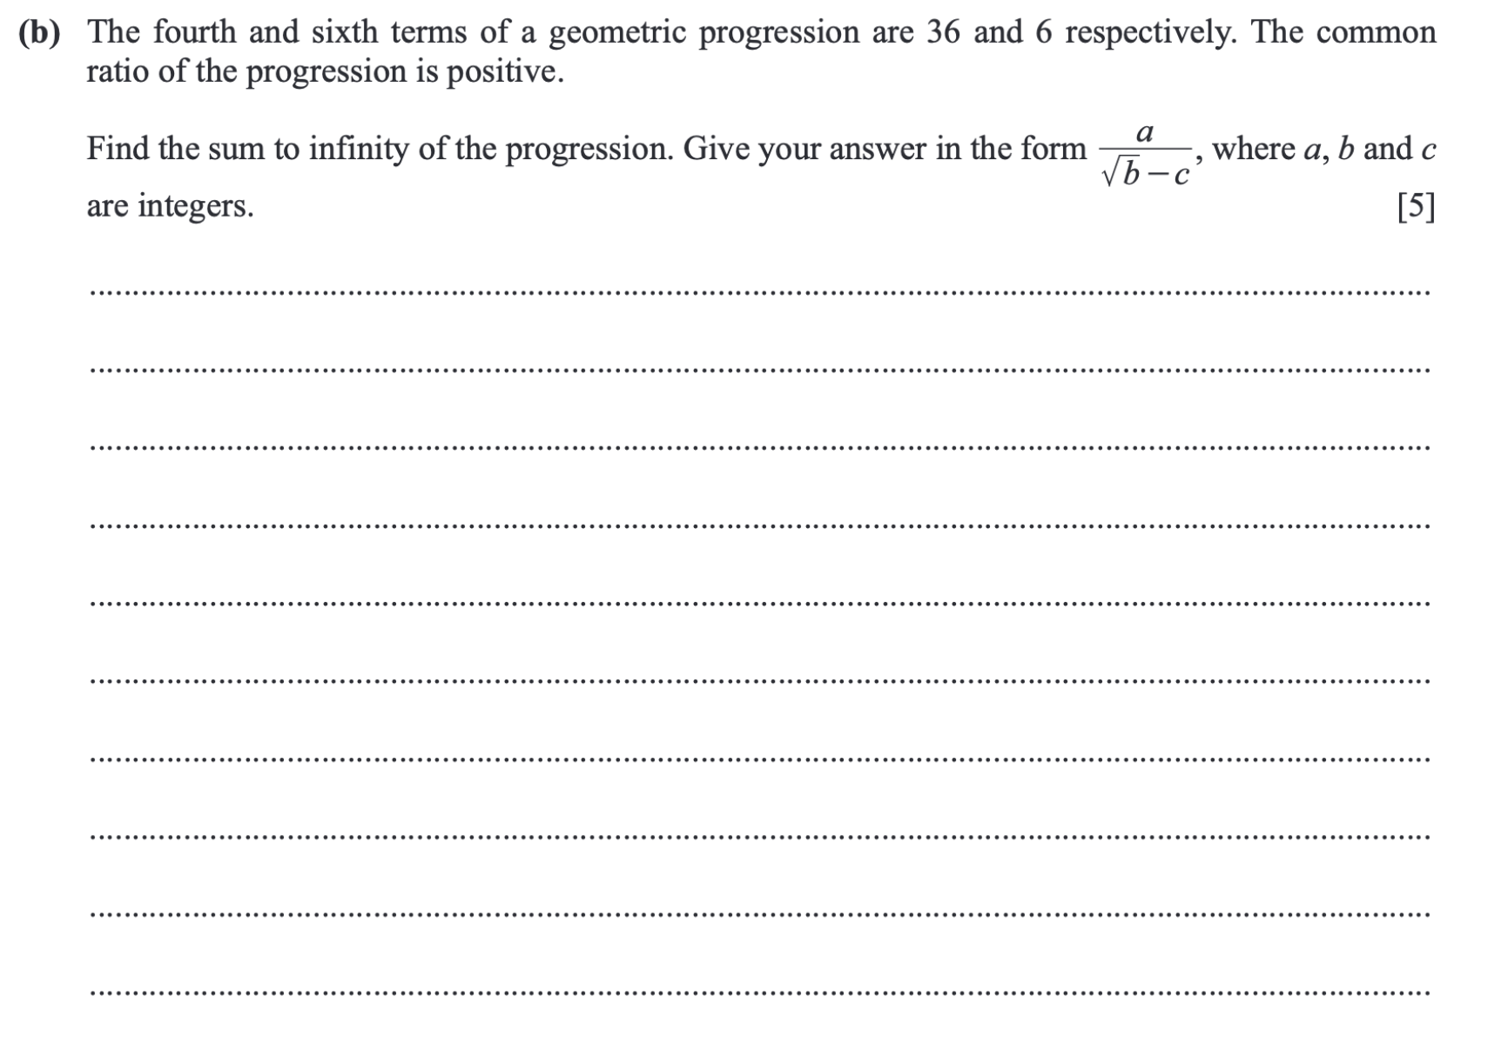

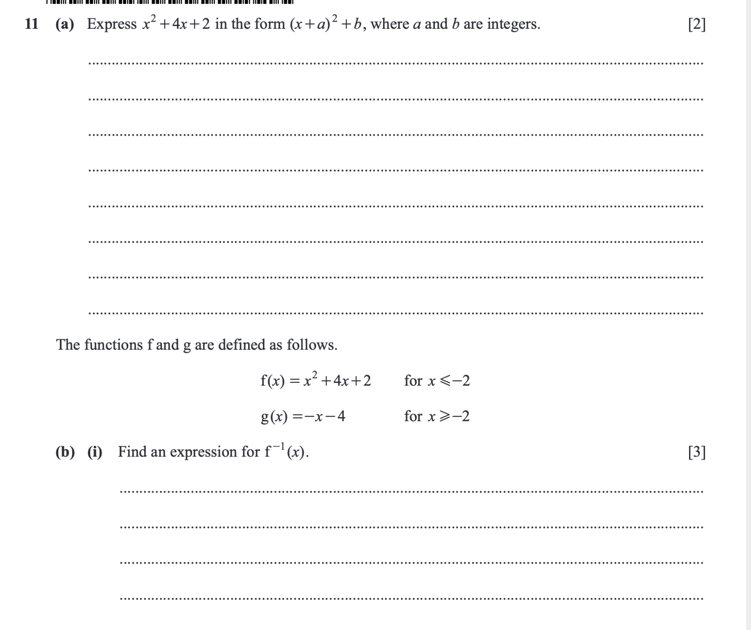



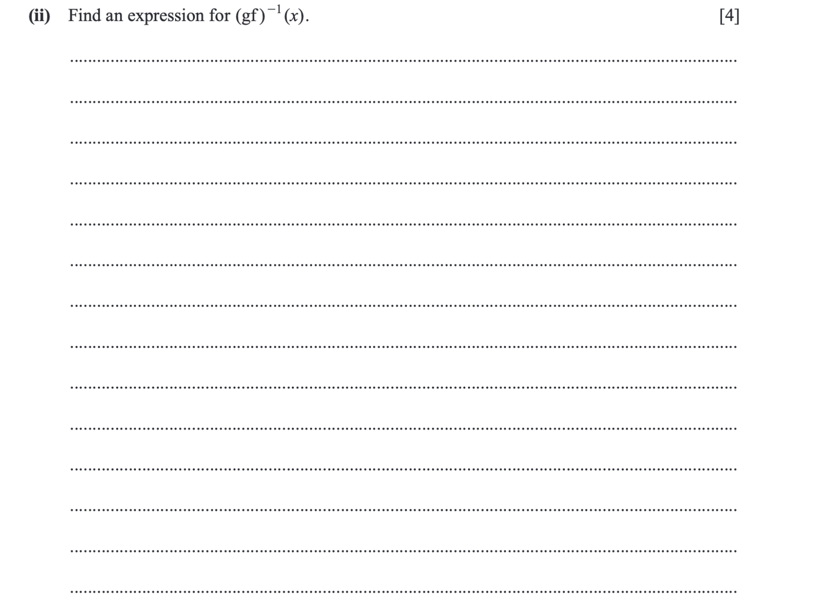

<https://dynamicpapers.com/wp-content/uploads/2015/09/9709_s24_qp_13.pdf>

(Questions 2(a),3(a),5(b),5(c),7(b),8,9(b),10(b),10(c),11(a),11(b))

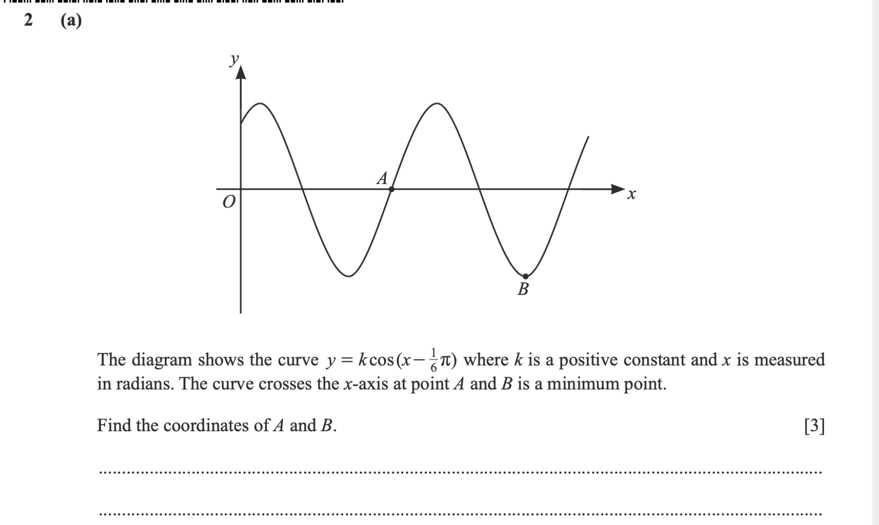

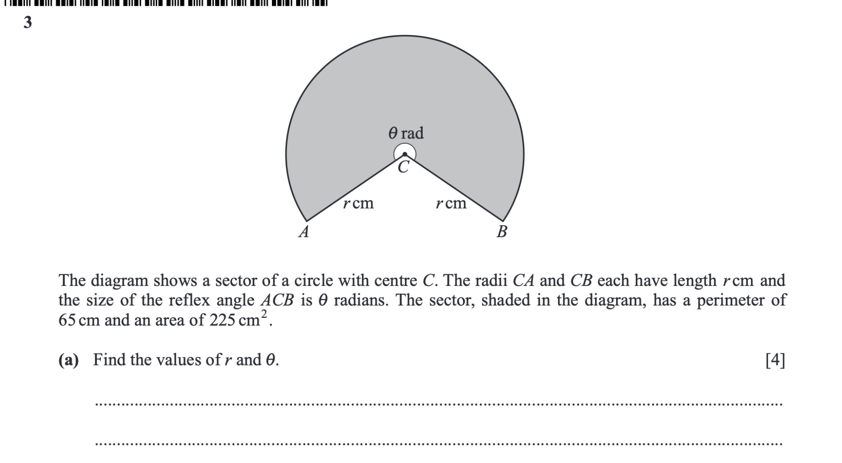

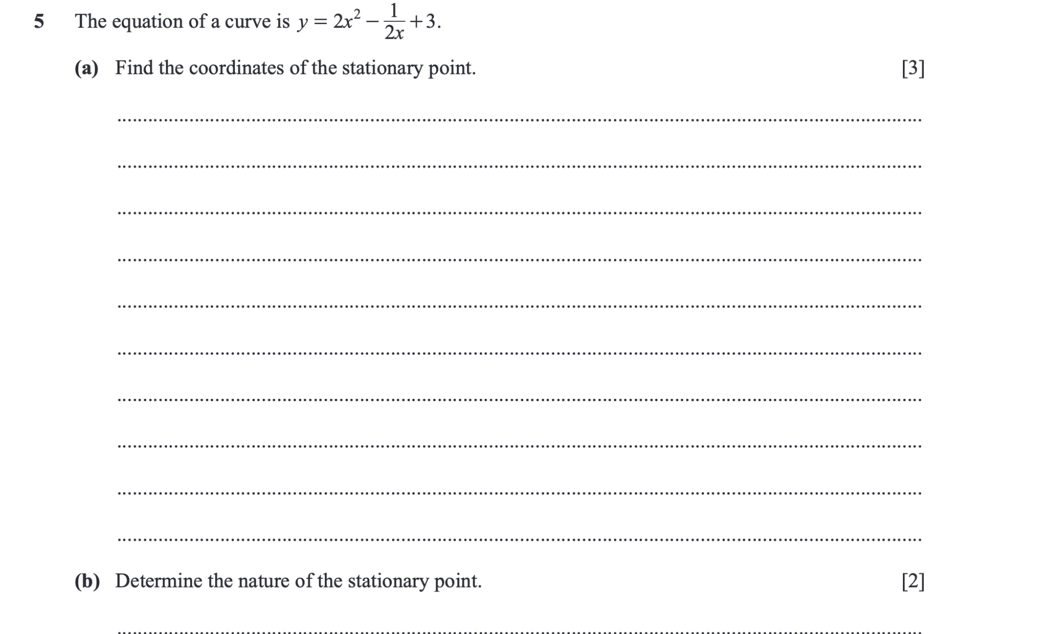

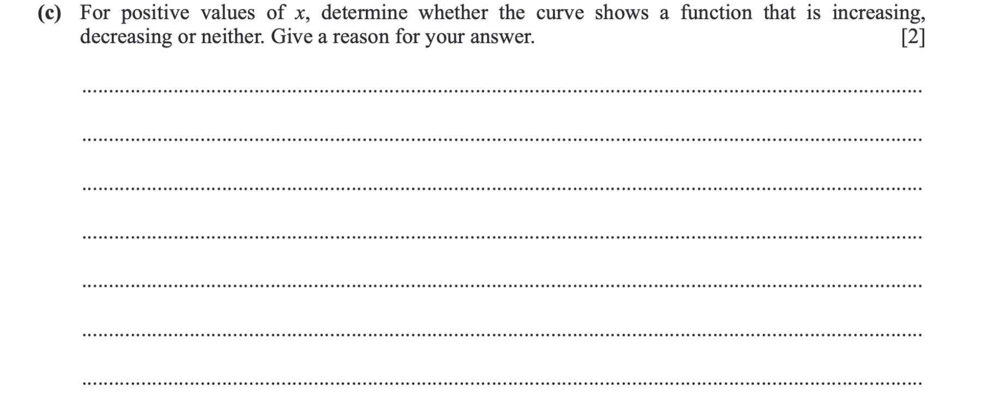

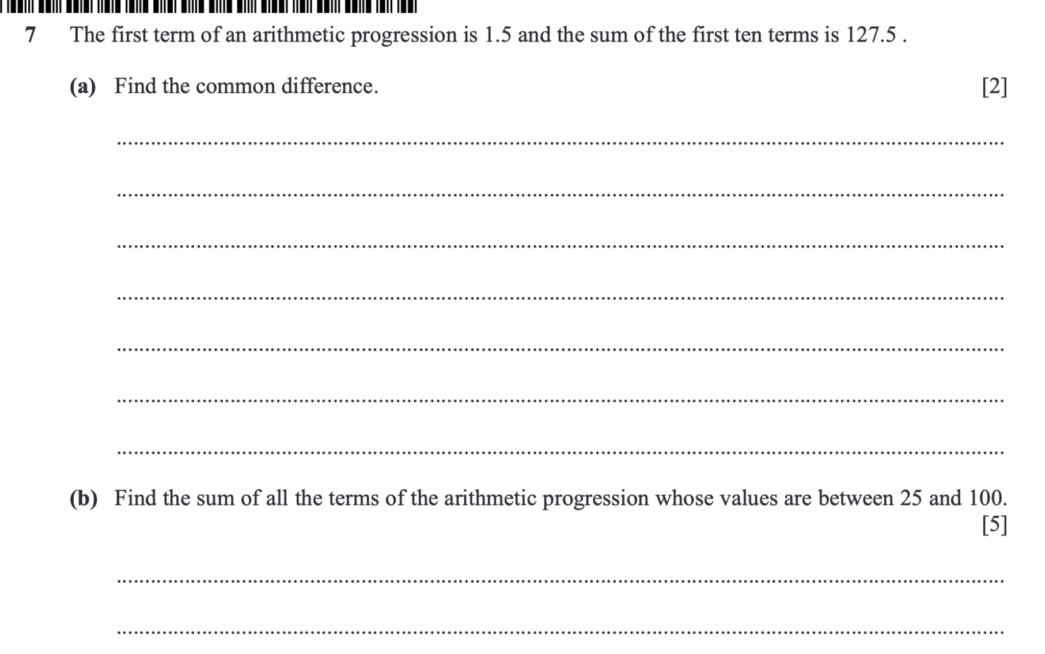

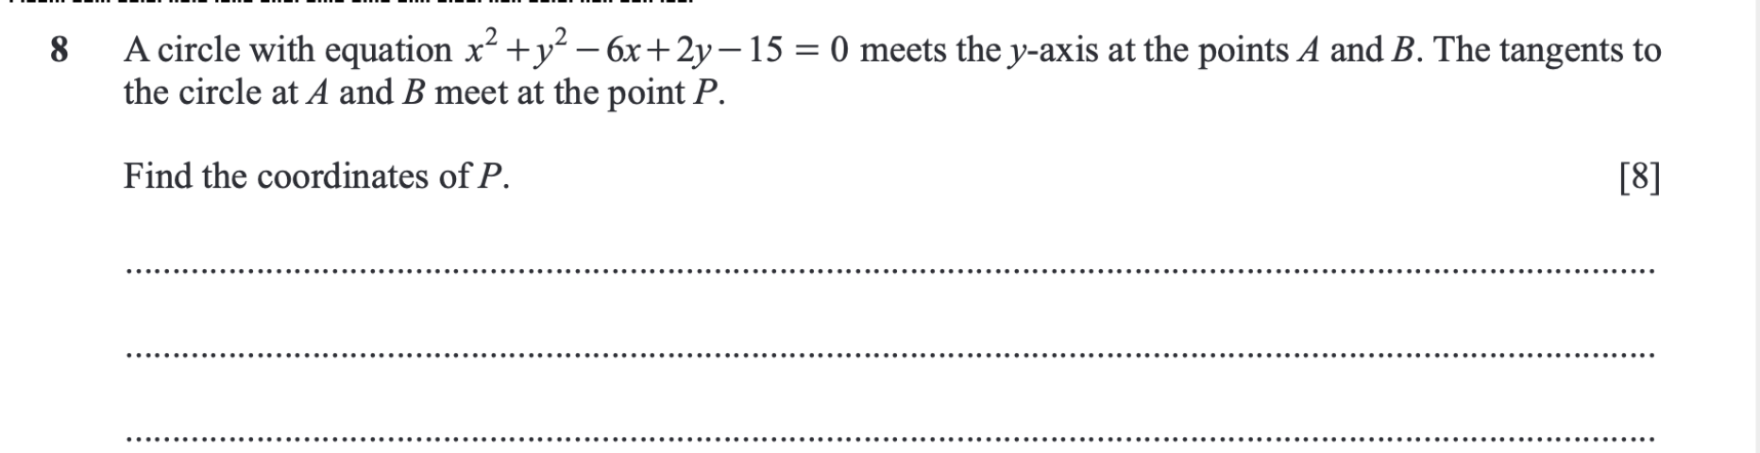

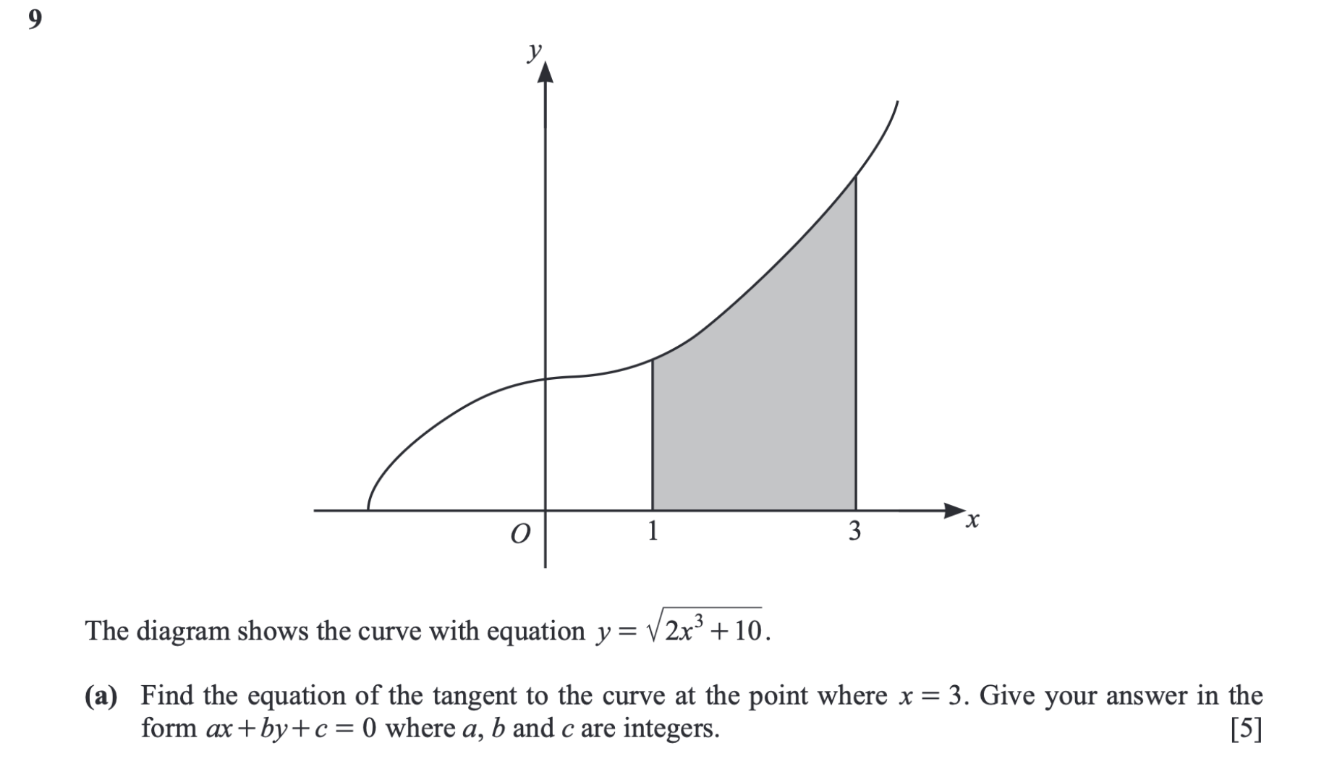

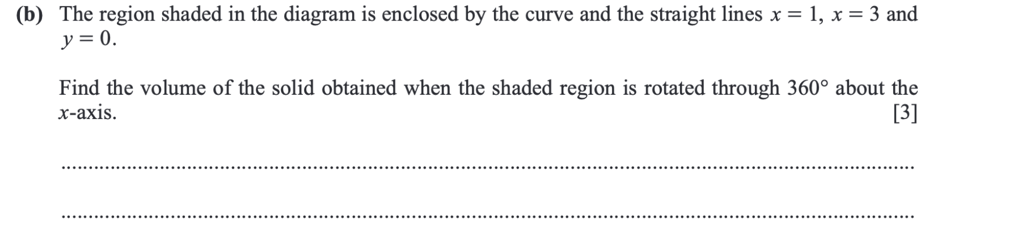

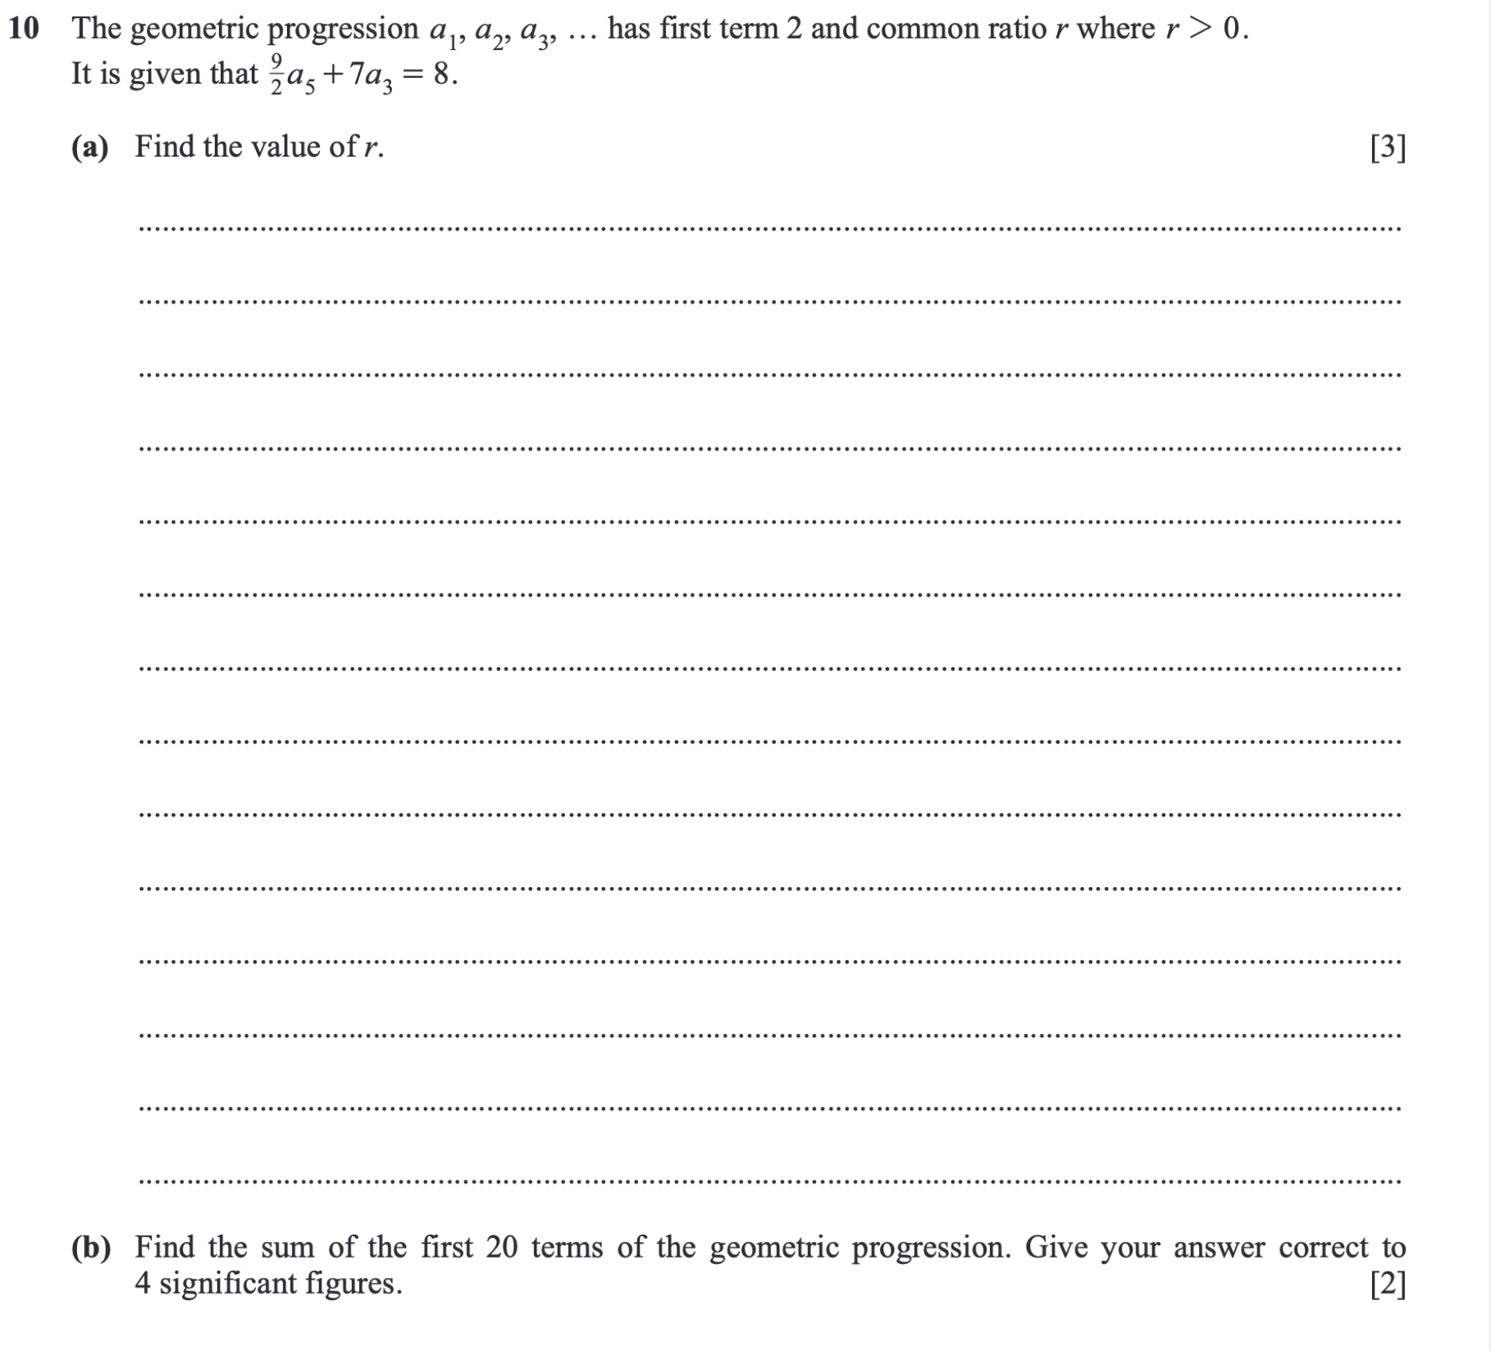

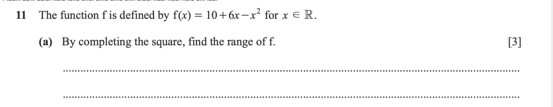

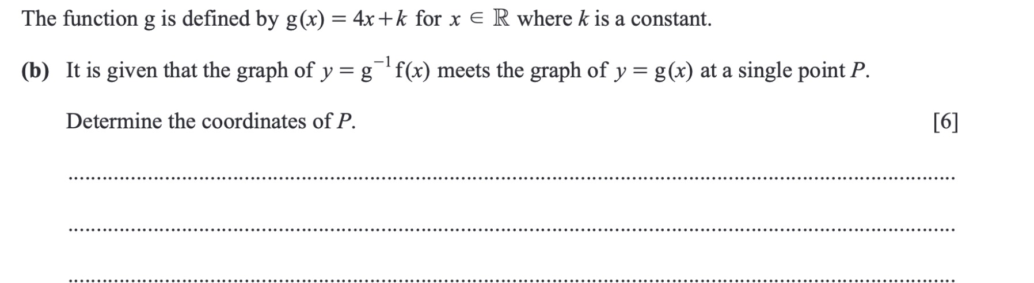

<https://dynamicpapers.com/wp-content/uploads/2015/09/9709_s25_qp_52.pdf>

(Questions 4,5,6)

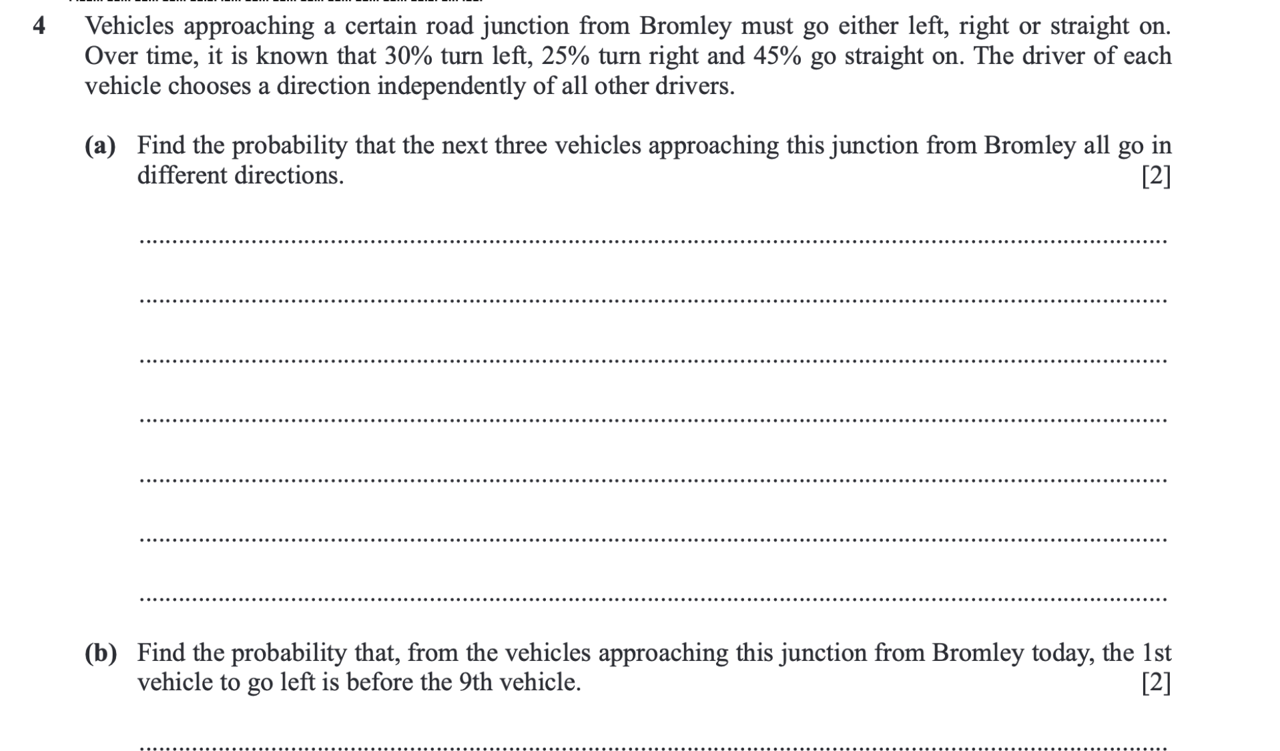

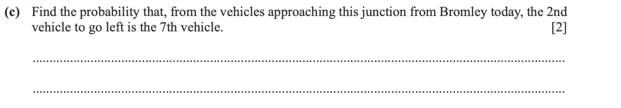

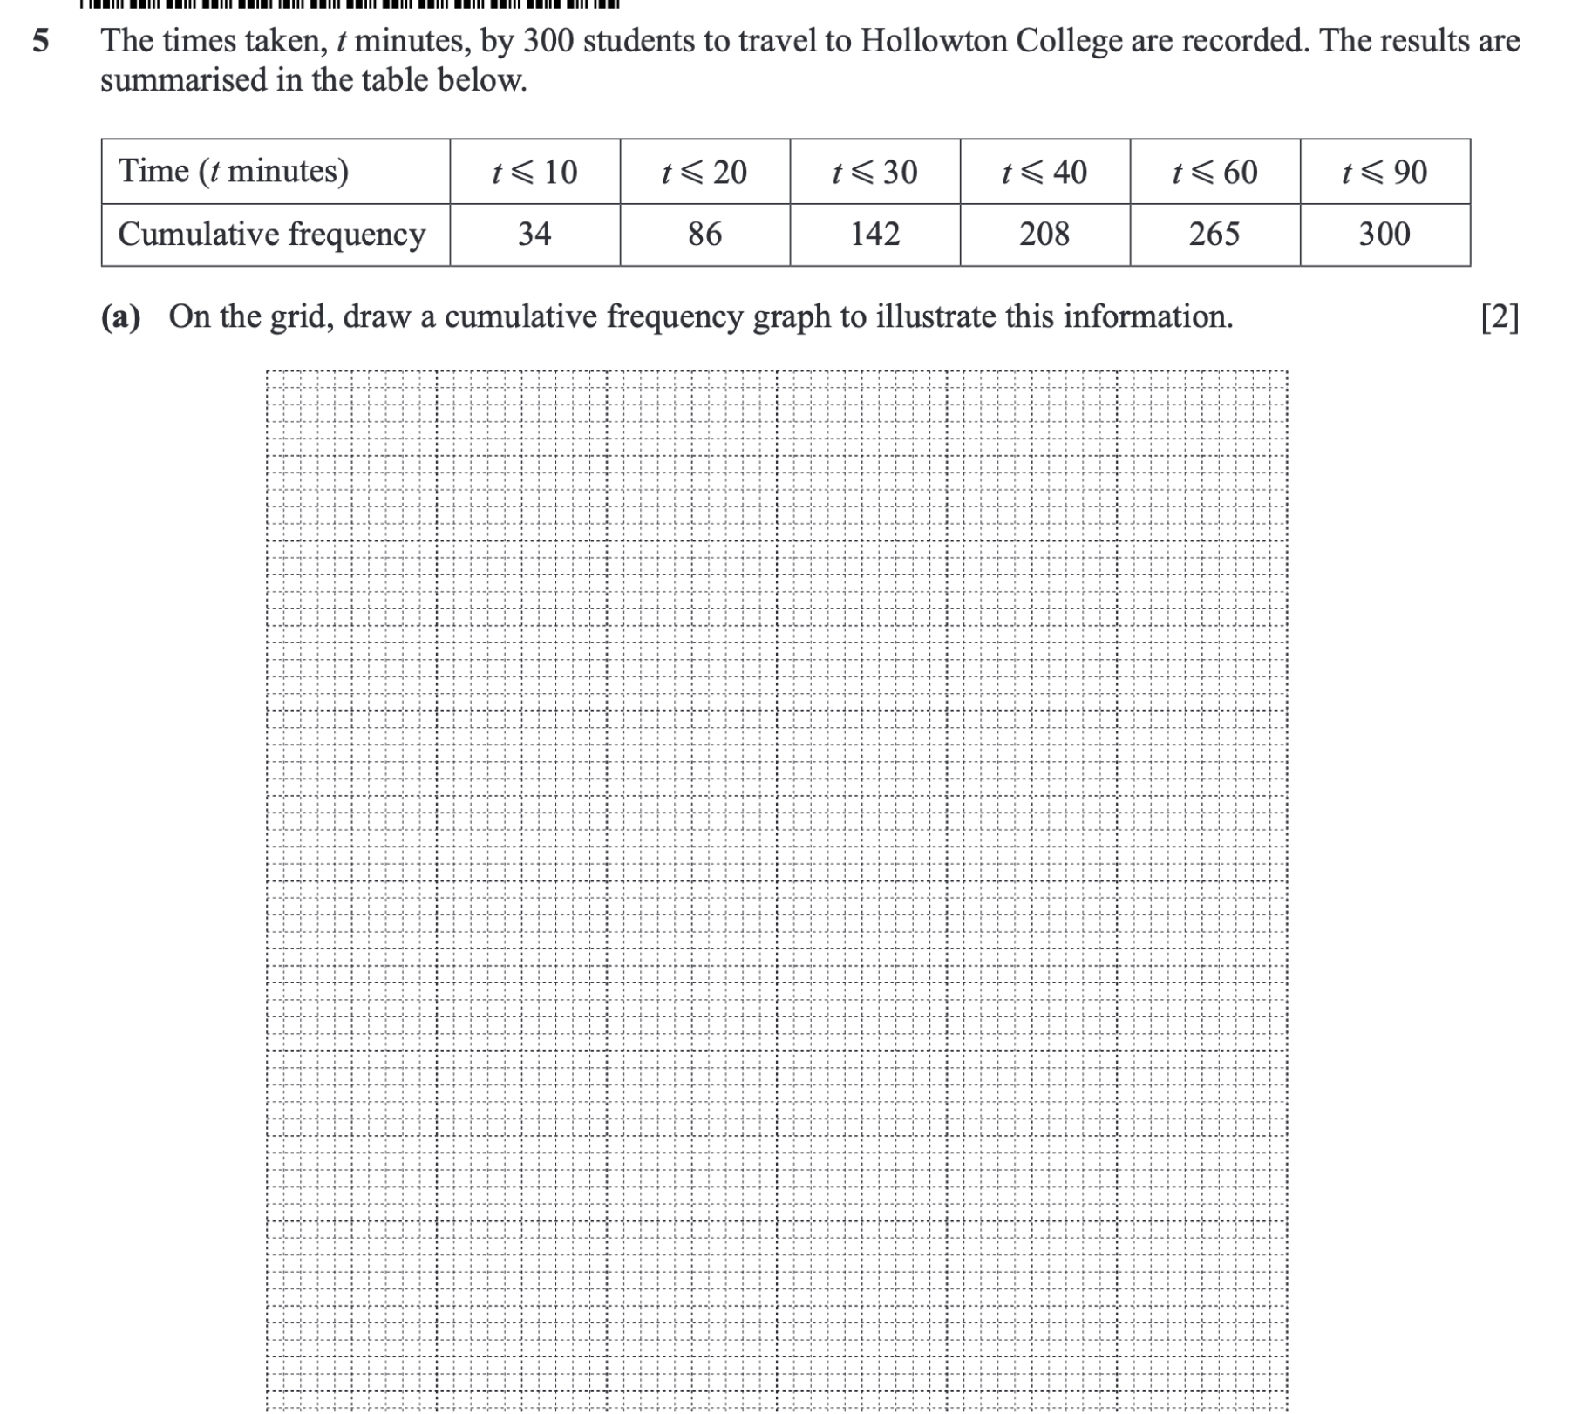

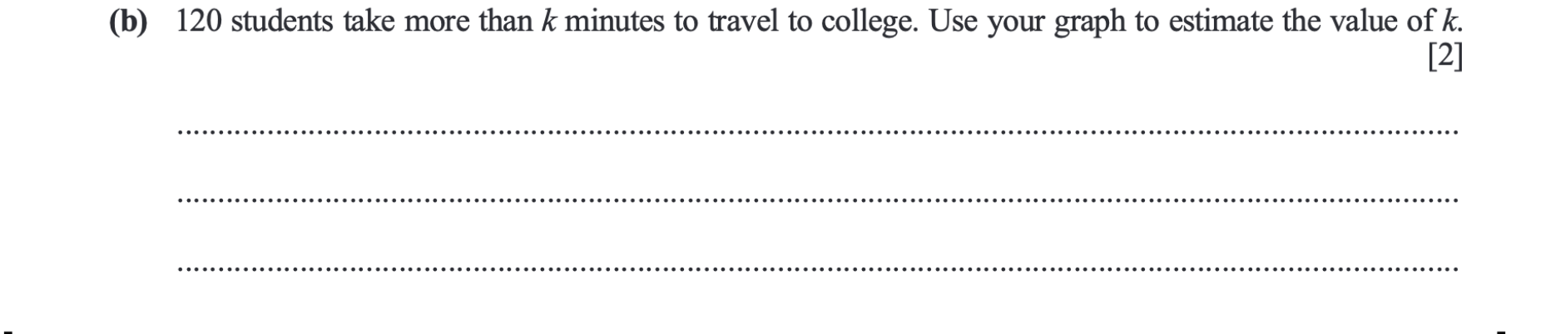 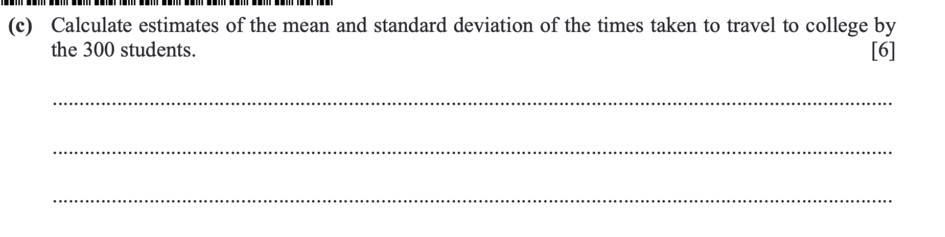

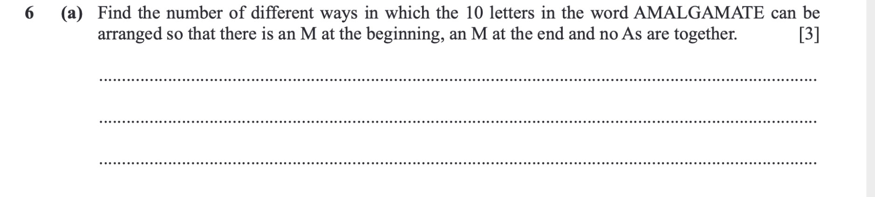

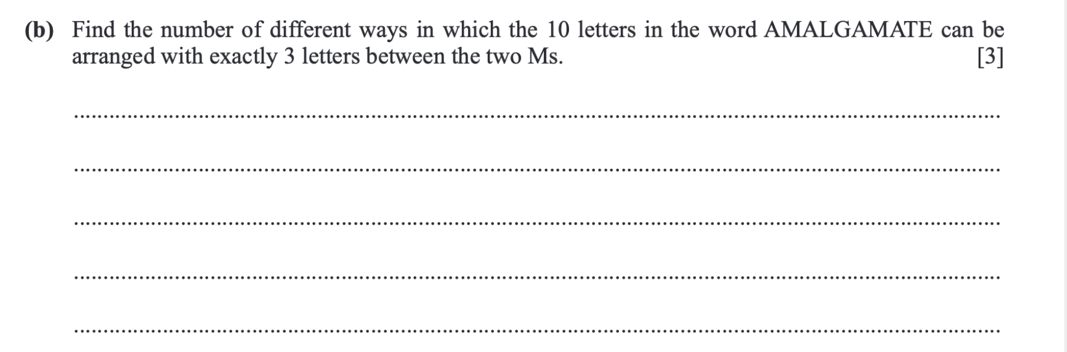

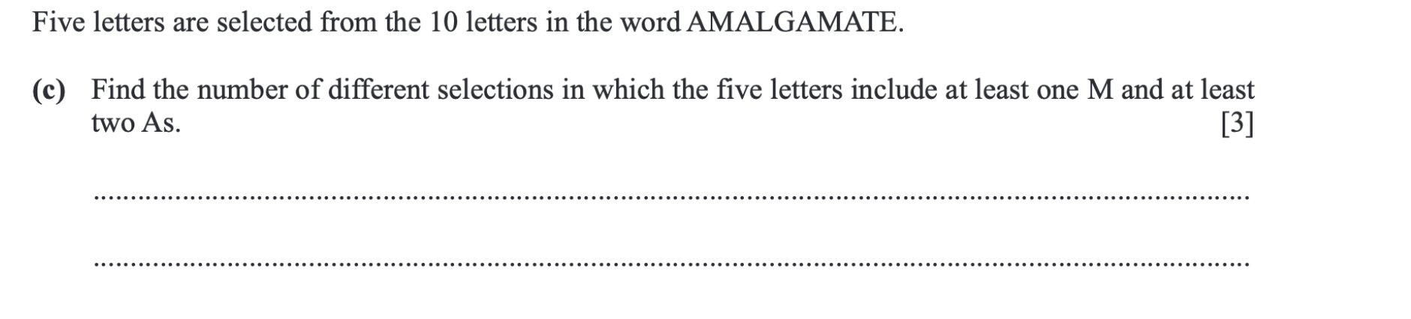

<https://dynamicpapers.com/wp-content/uploads/2015/09/9709_w24_qp_53.pdf>

(Questions 1(a), 4(a), 5(c), 6(c), 6(d))

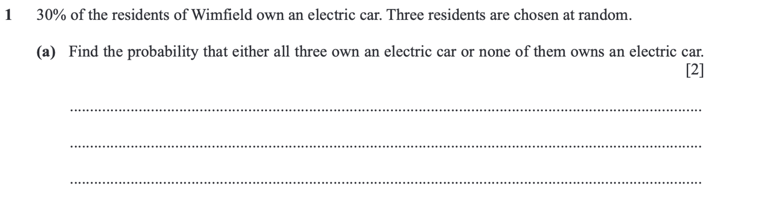

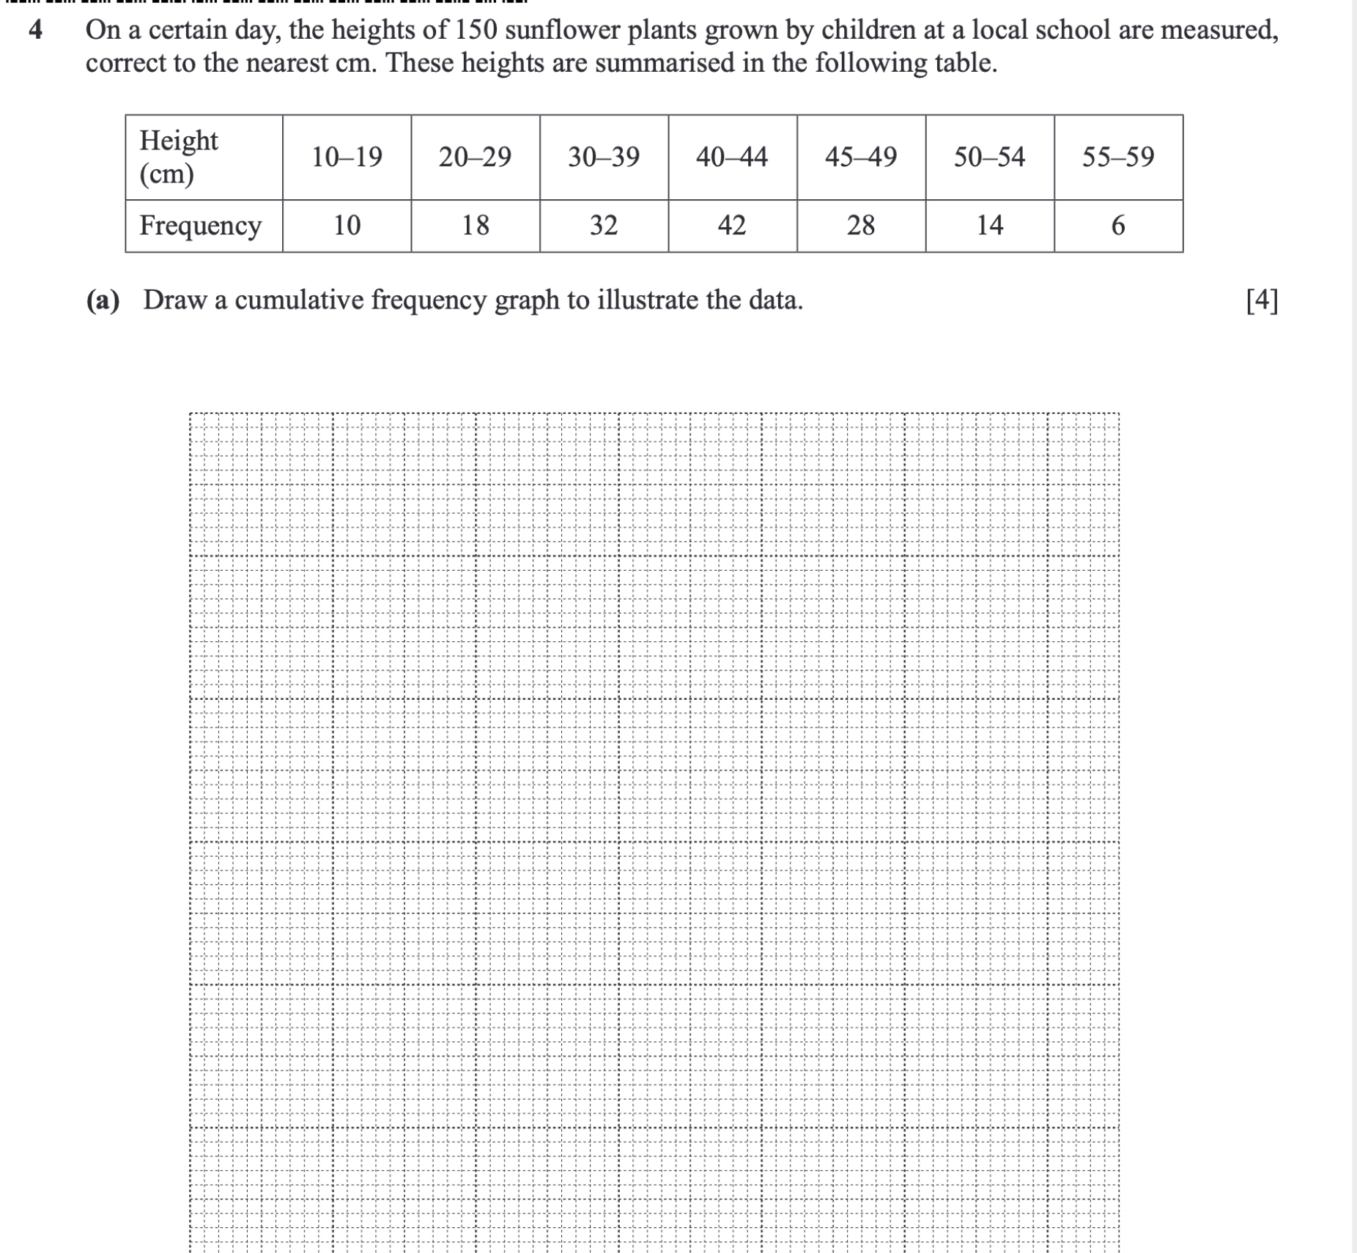

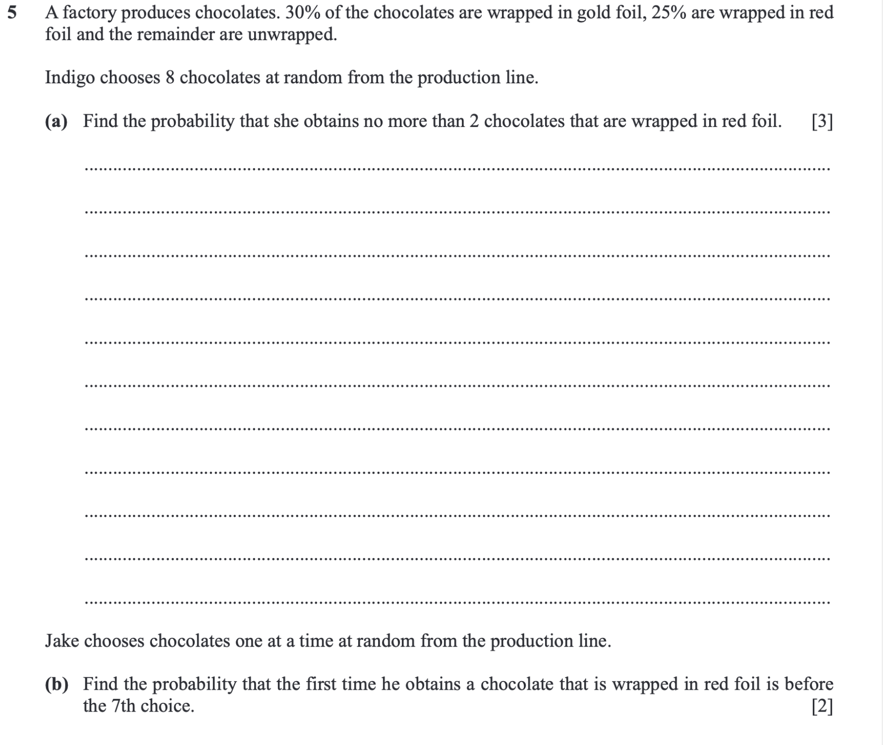

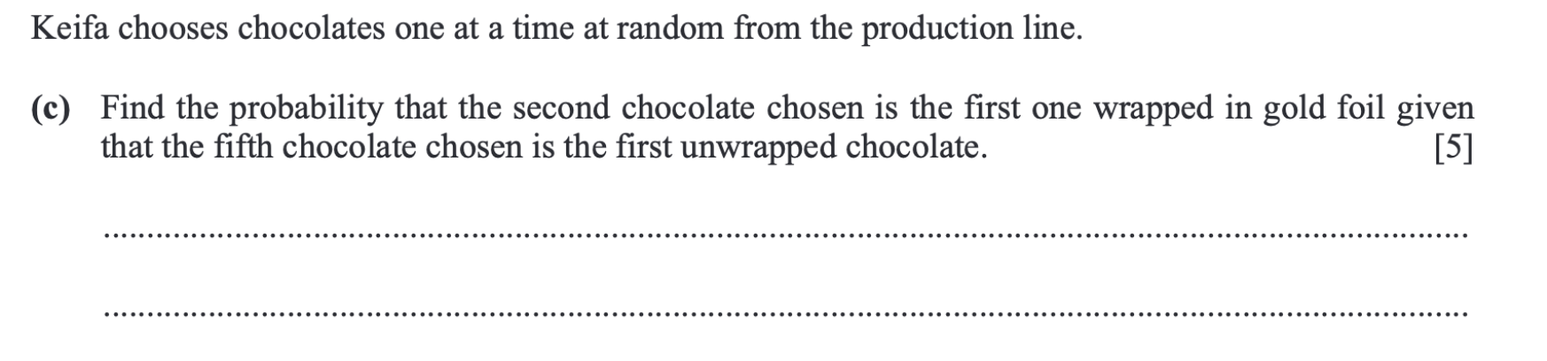

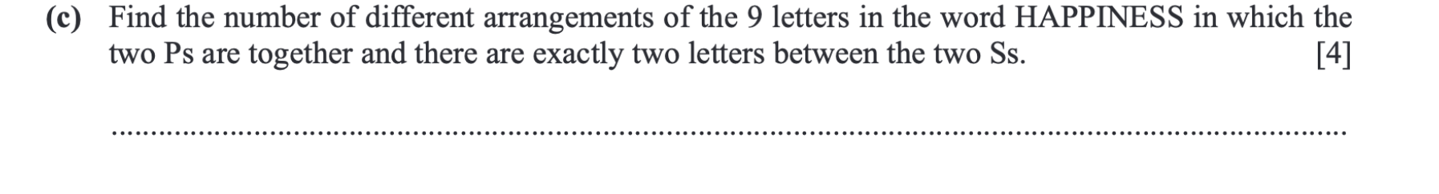

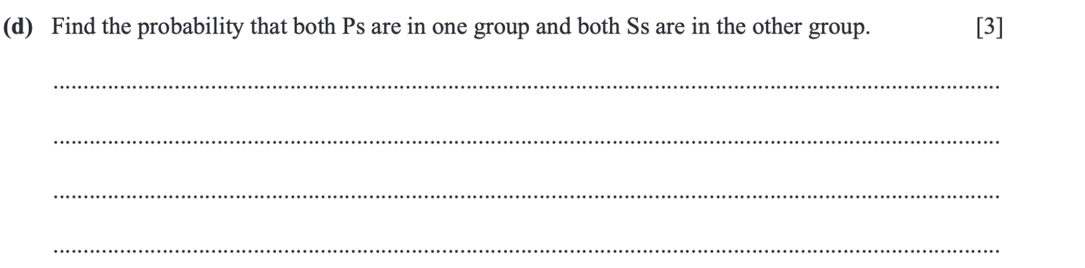

<https://dynamicpapers.com/wp-content/uploads/2015/09/9709_w24_qp_51.pdf>

(Questions 1, 3, 4, 7)

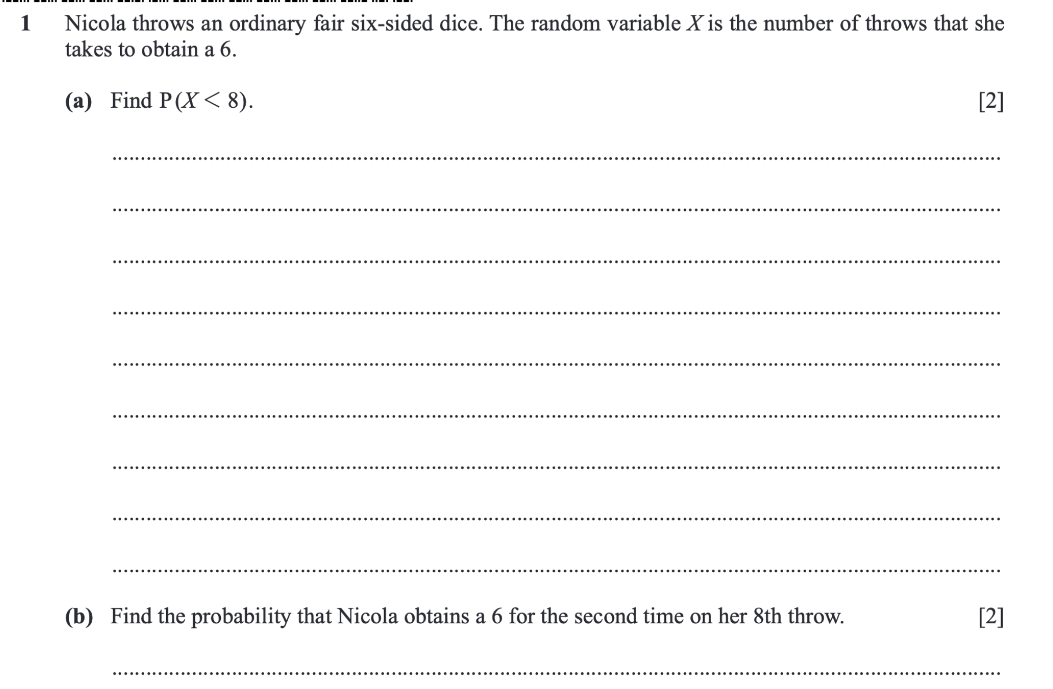

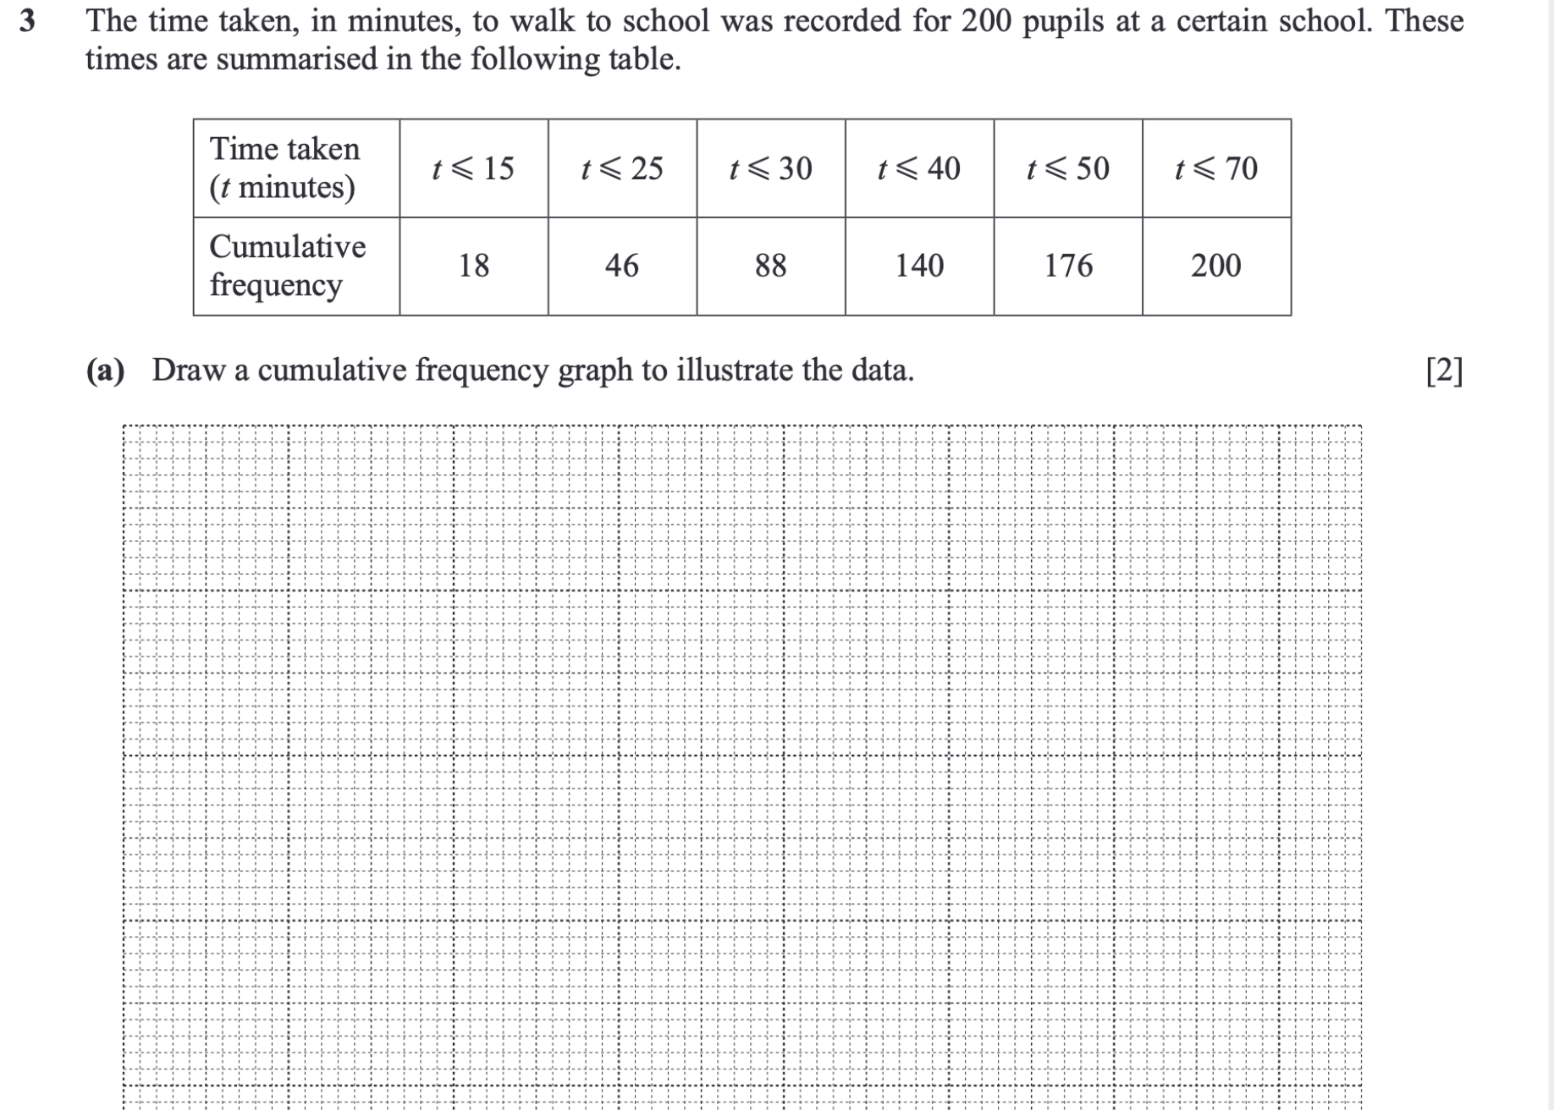

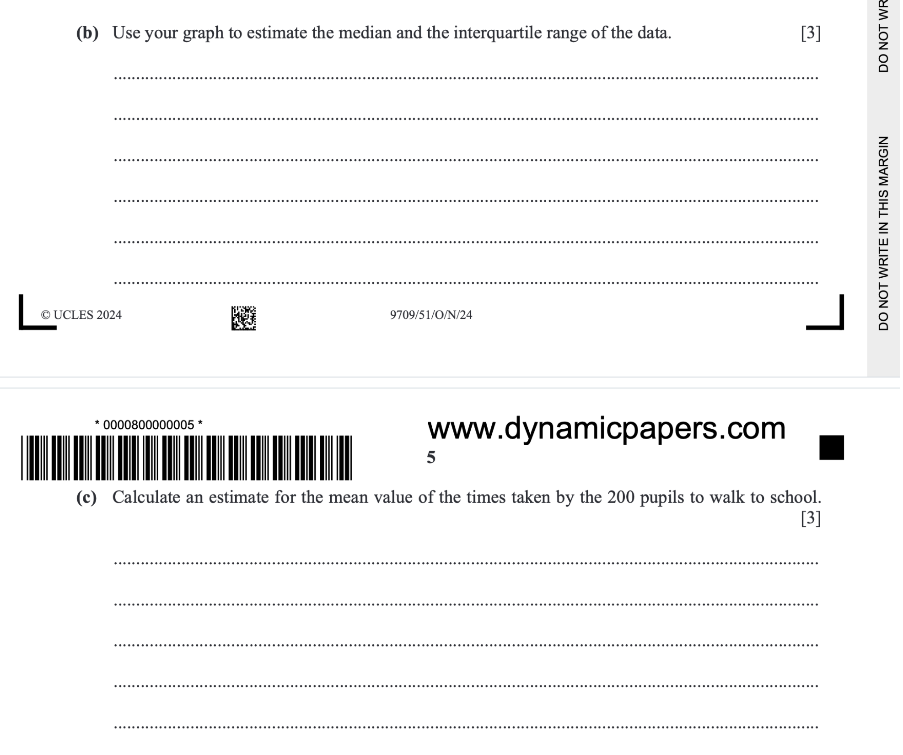

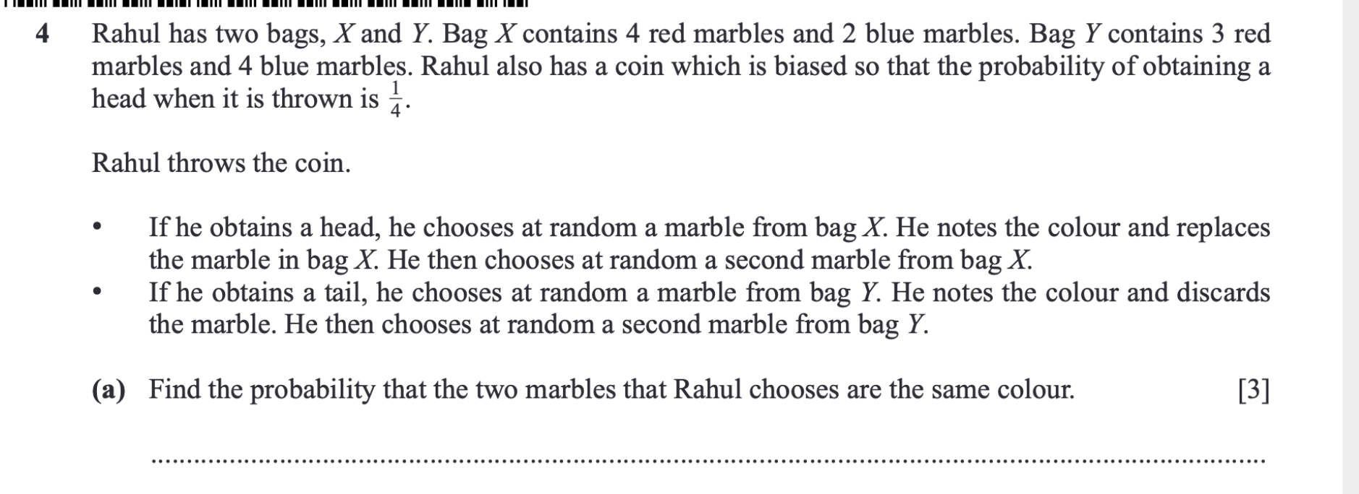

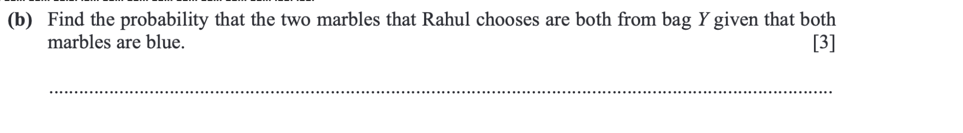

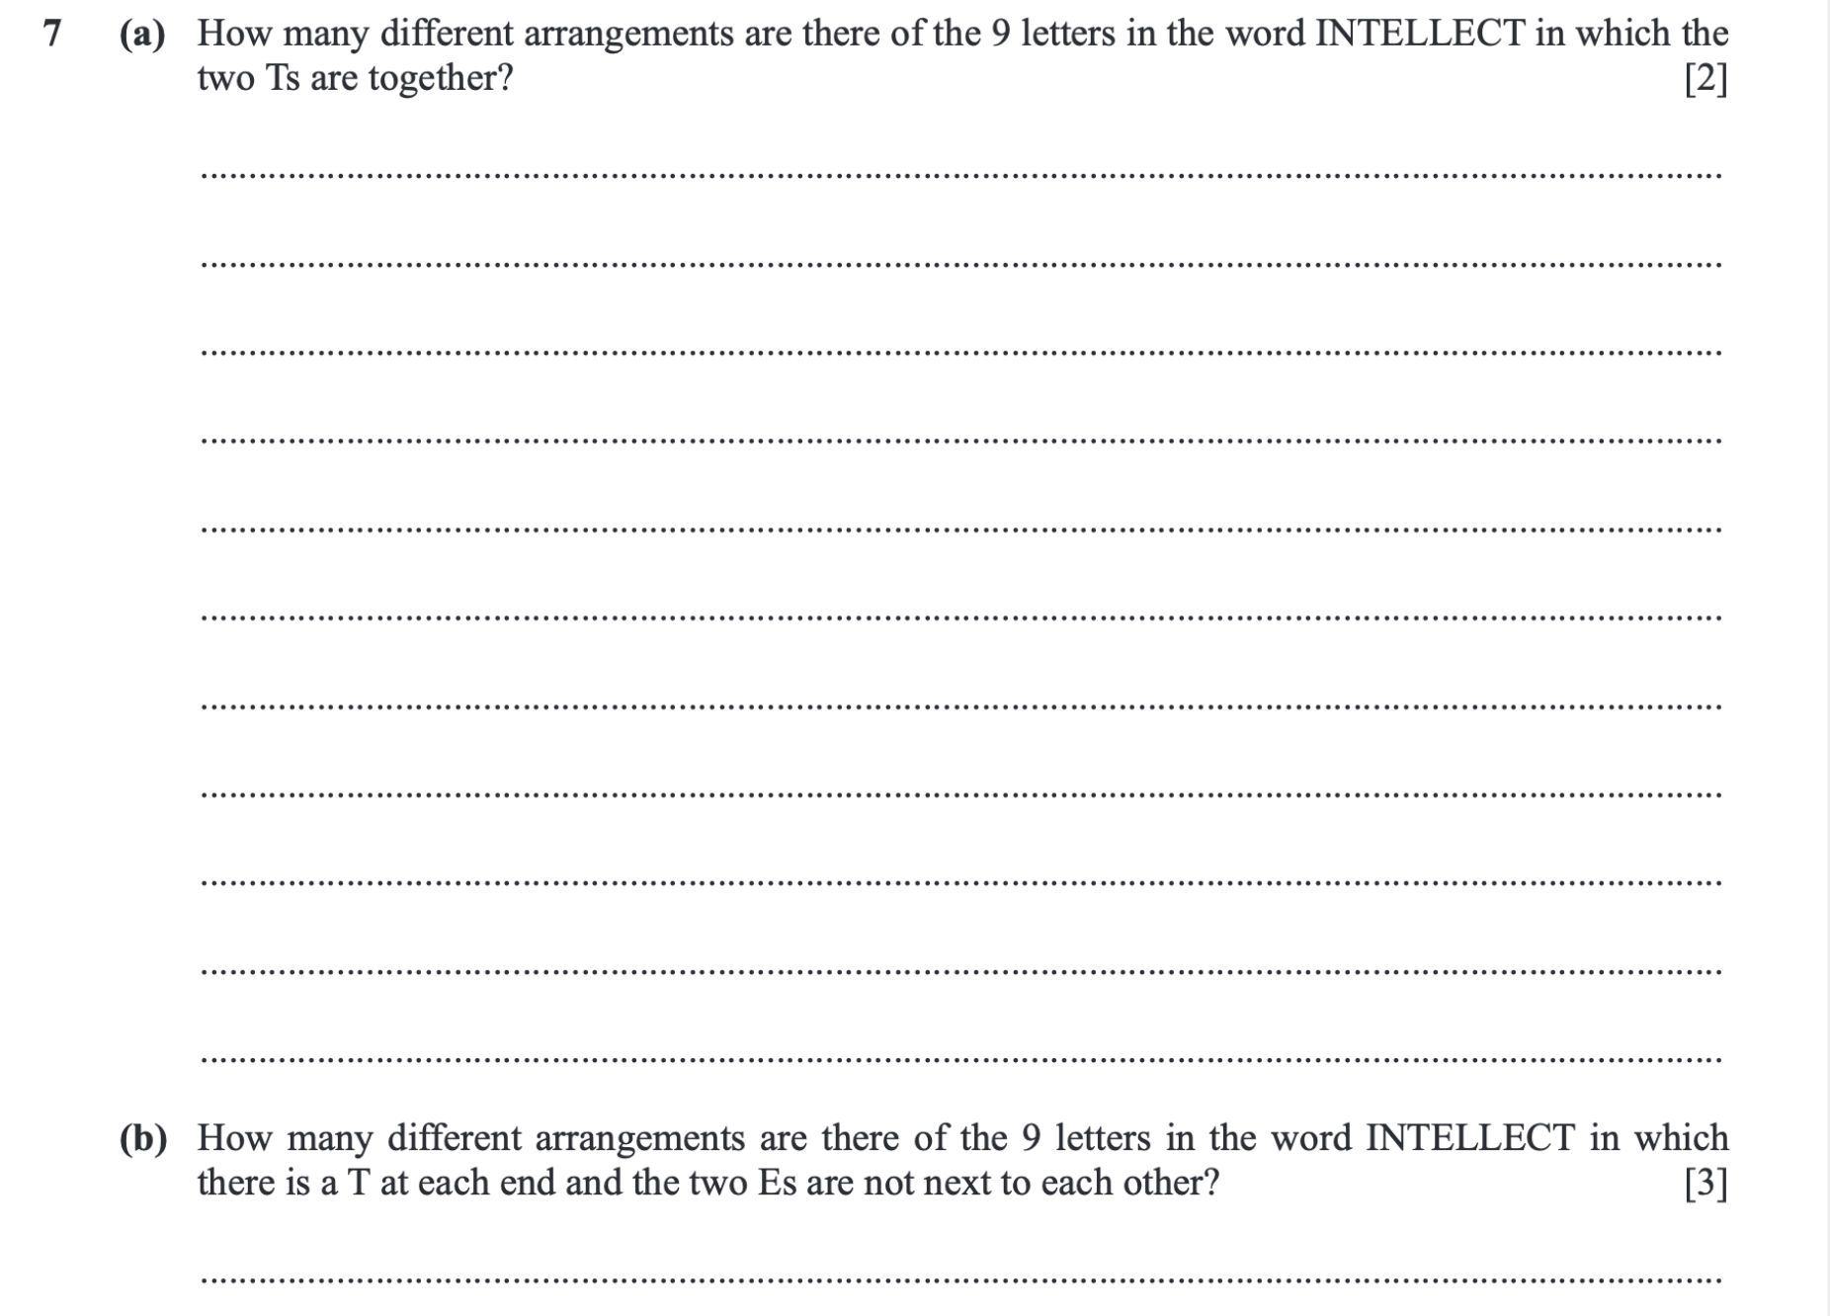

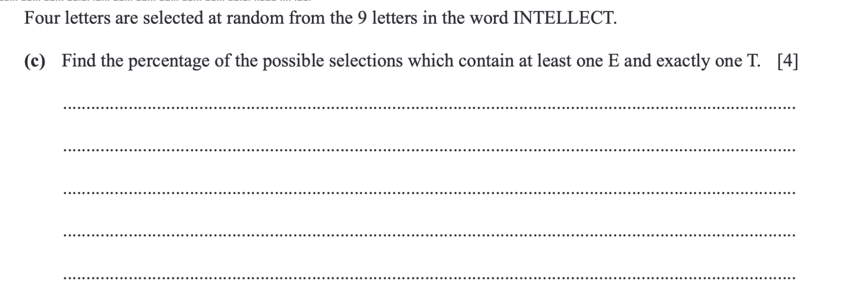

<https://dynamicpapers.com/wp-content/uploads/2015/09/9709_w22_qp_51.pdf>

(Questions 1 and 6)

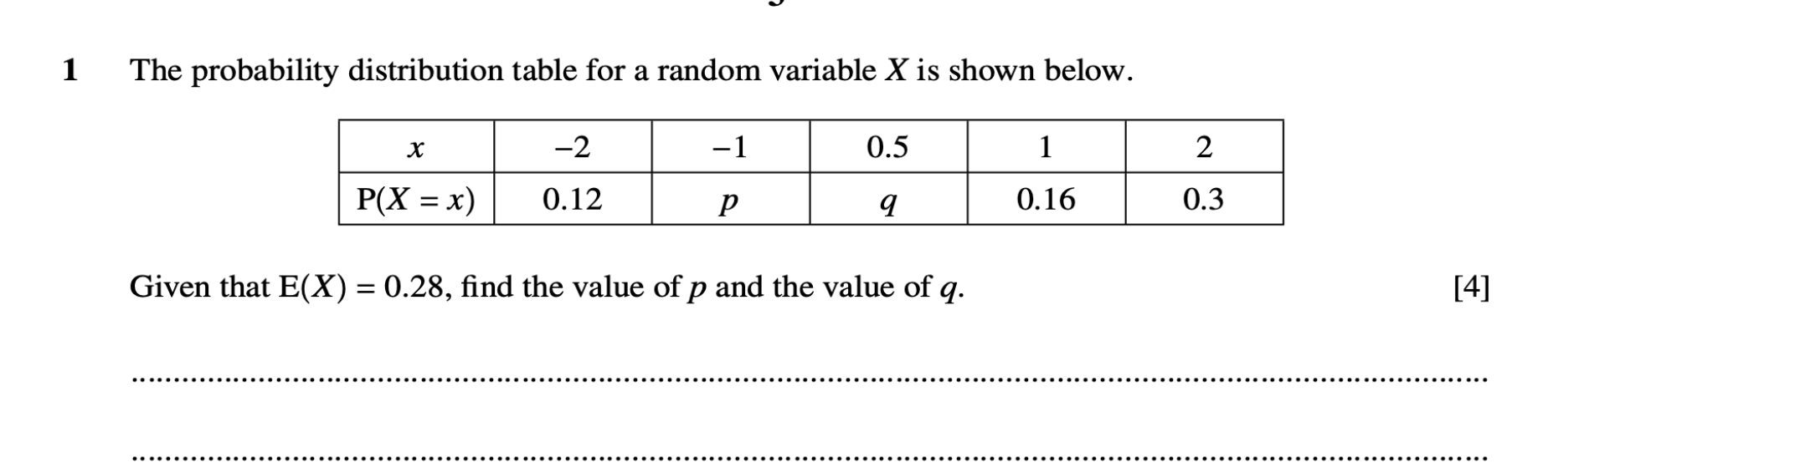

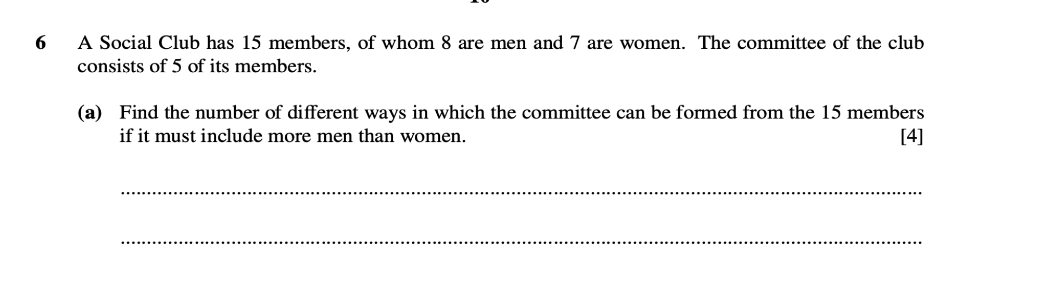

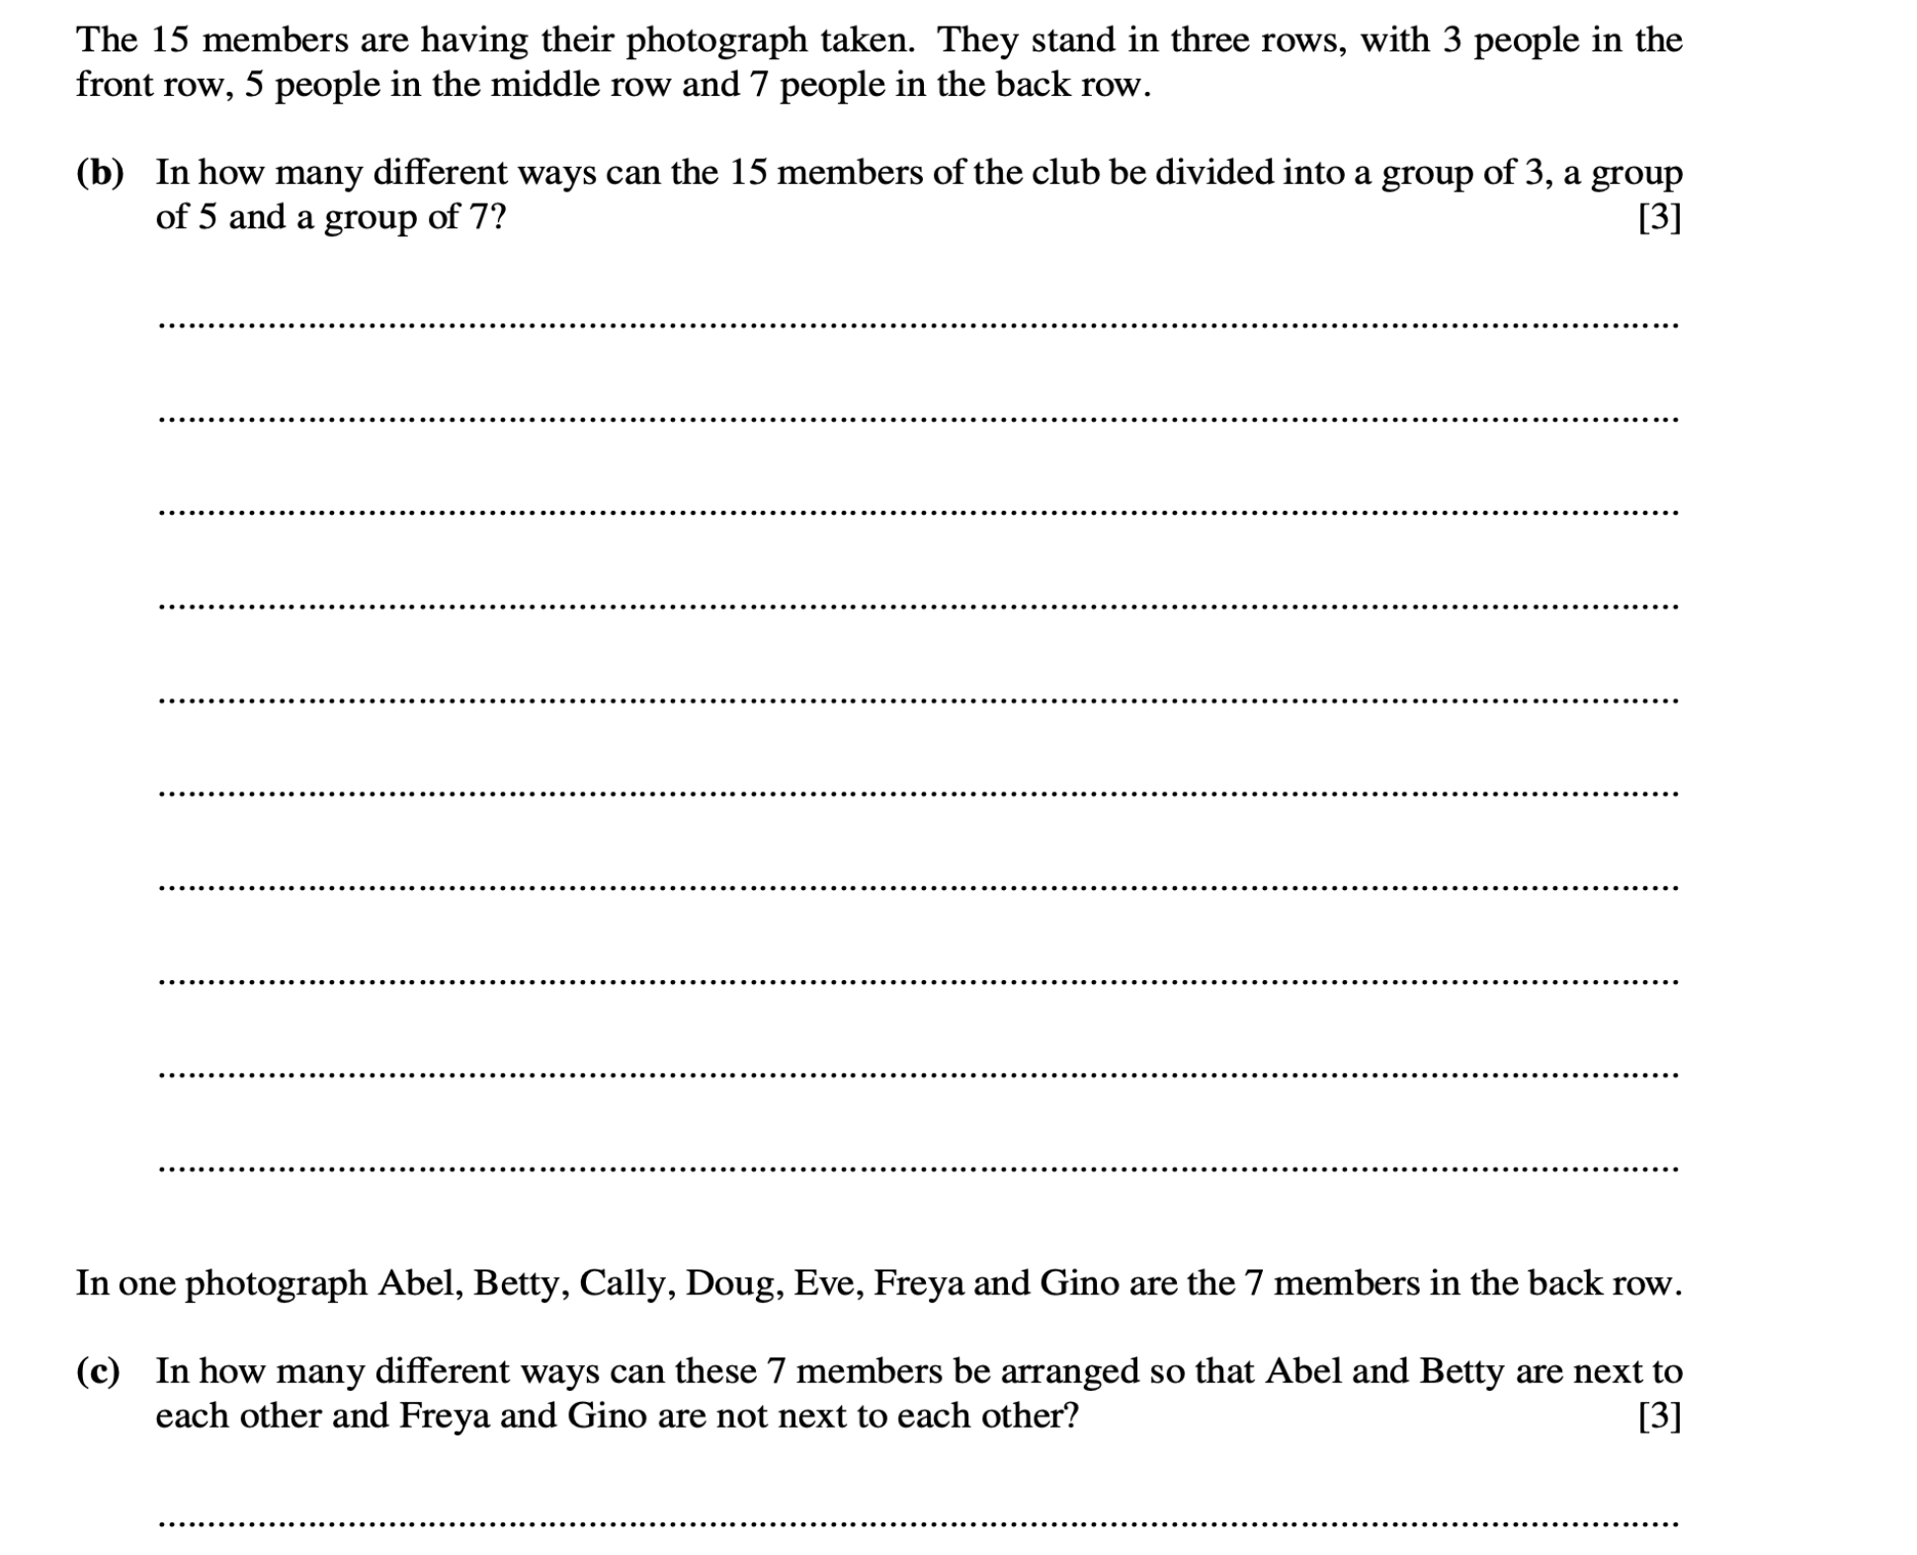

<https://dynamicpapers.com/wp-content/uploads/2015/09/9709_w22_qp_52.pdf>

(Question 7)

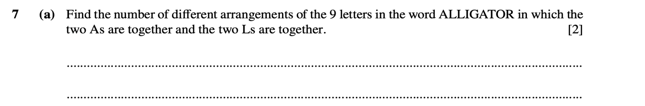

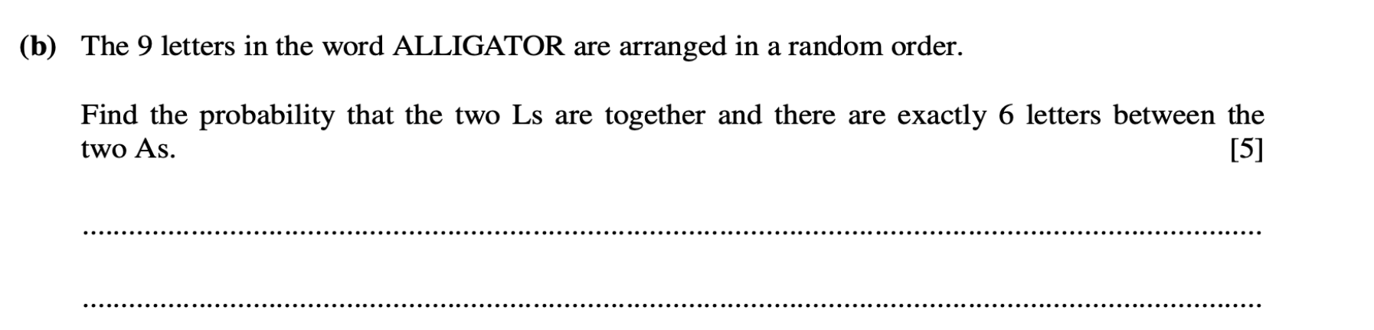

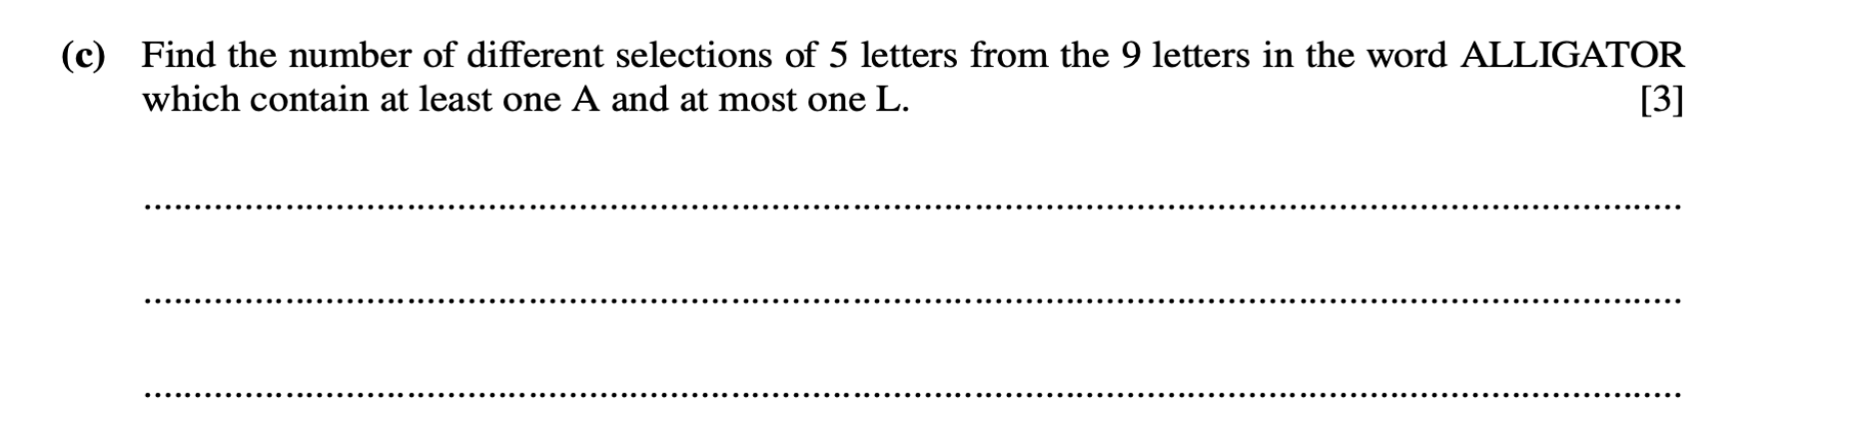

<https://dynamicpapers.com/wp-content/uploads/2015/09/9709_w24_qp_52.pdf>

(Questions 2, 7)

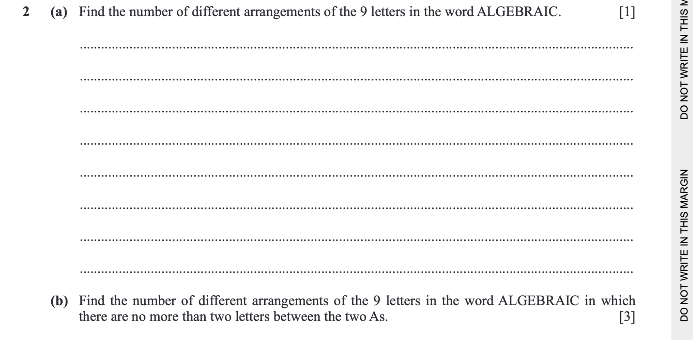

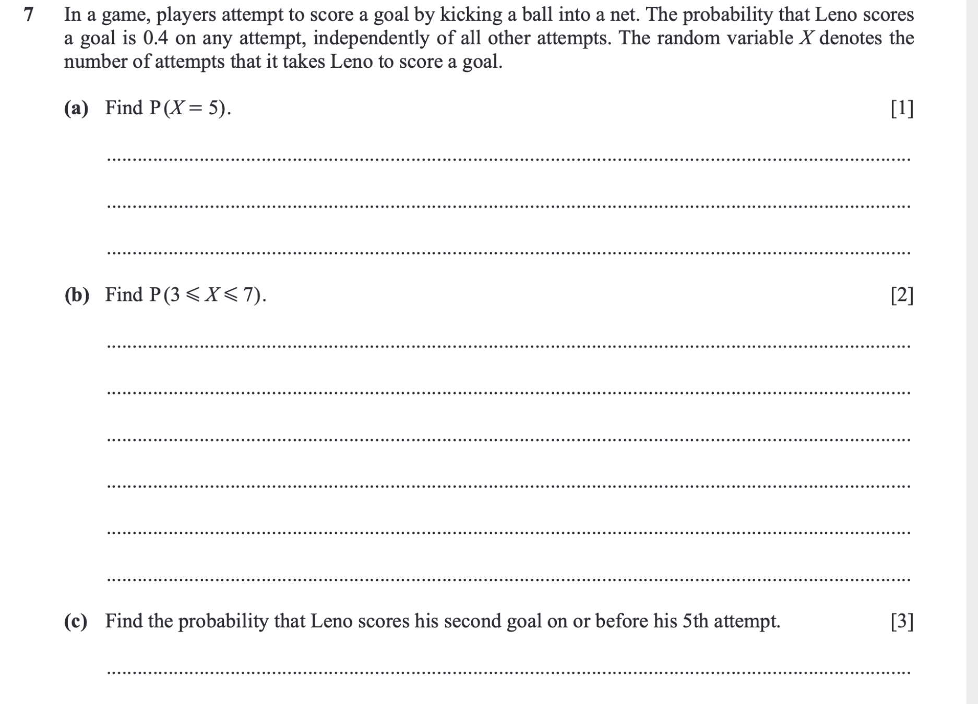

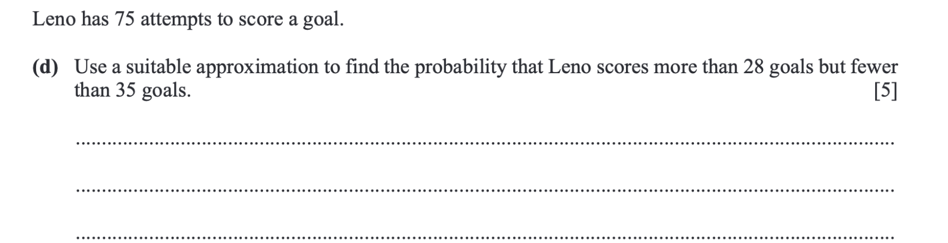

<https://dynamicpapers.com/wp-content/uploads/2015/09/9709_w21_qp_53.pdf>

(Question 5)

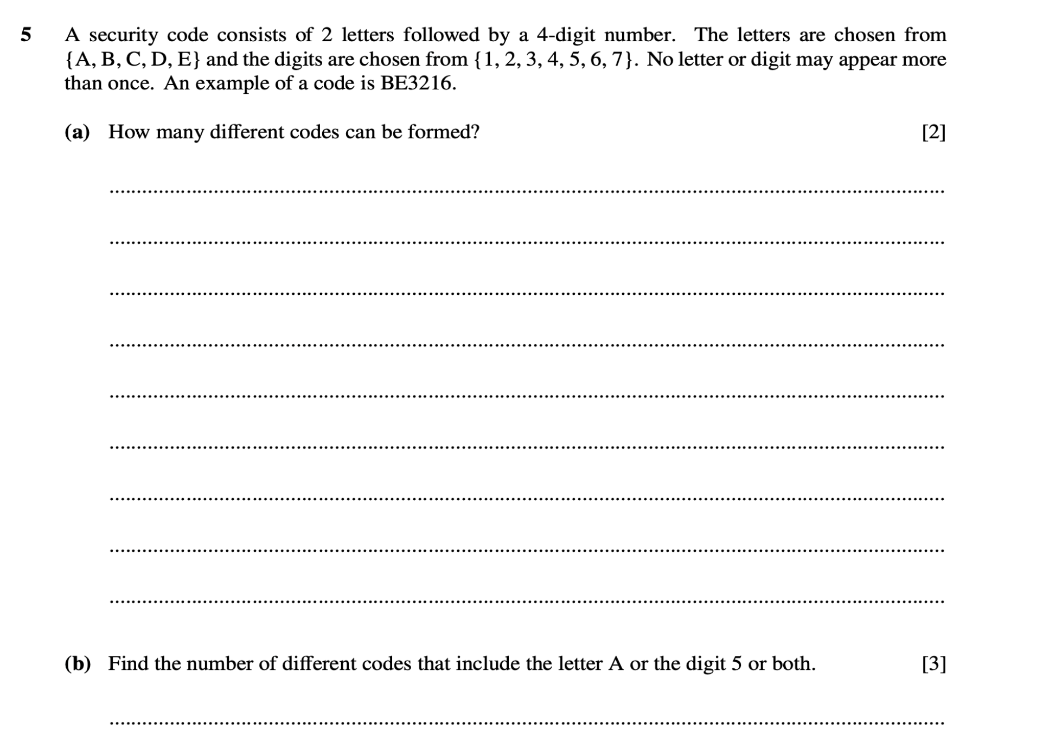

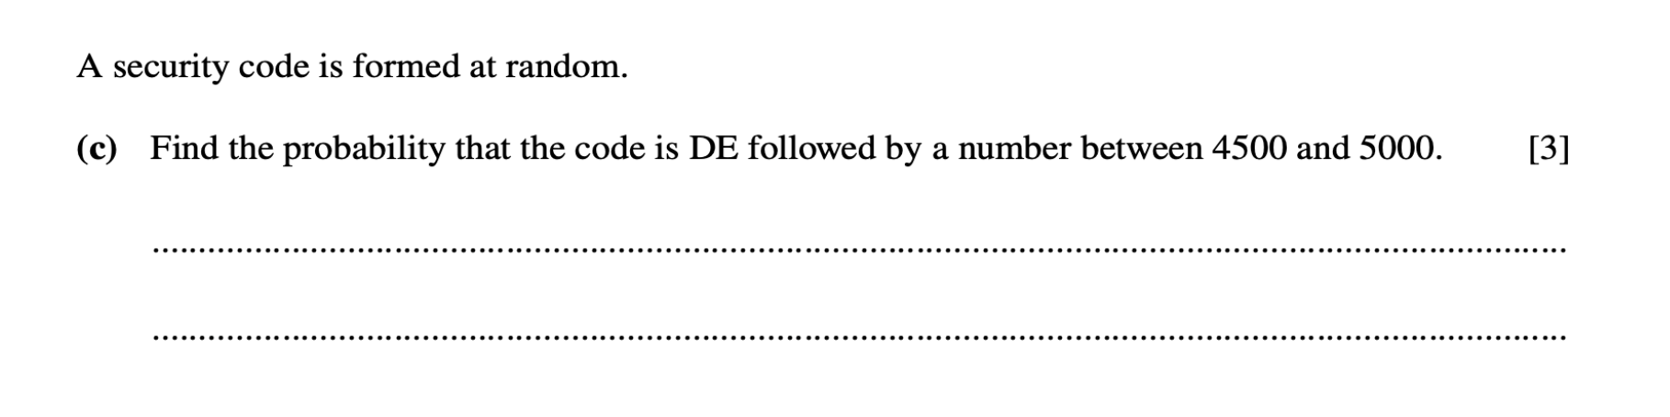

<https://dynamicpapers.com/wp-content/uploads/2015/09/9709_s21_qp_53.pdf>

(Question 6)

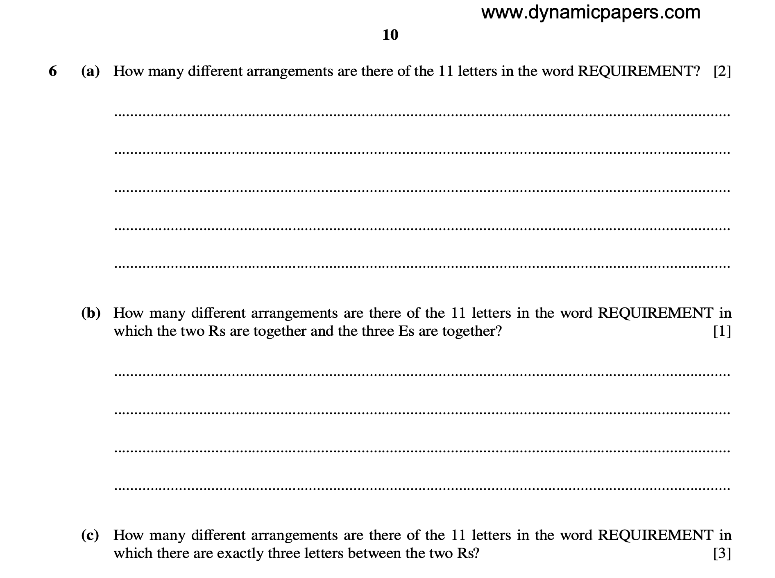

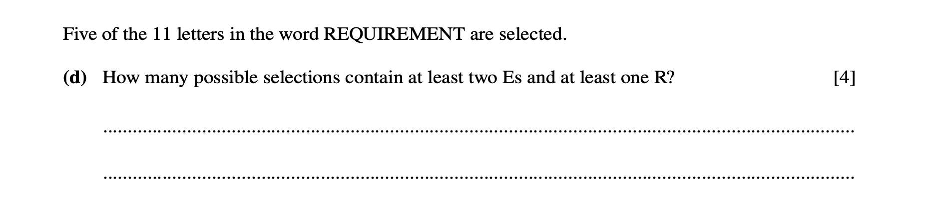

<https://dynamicpapers.com/wp-content/uploads/2015/09/9709_s24_qp_53.pdf>

(Question 5,6)

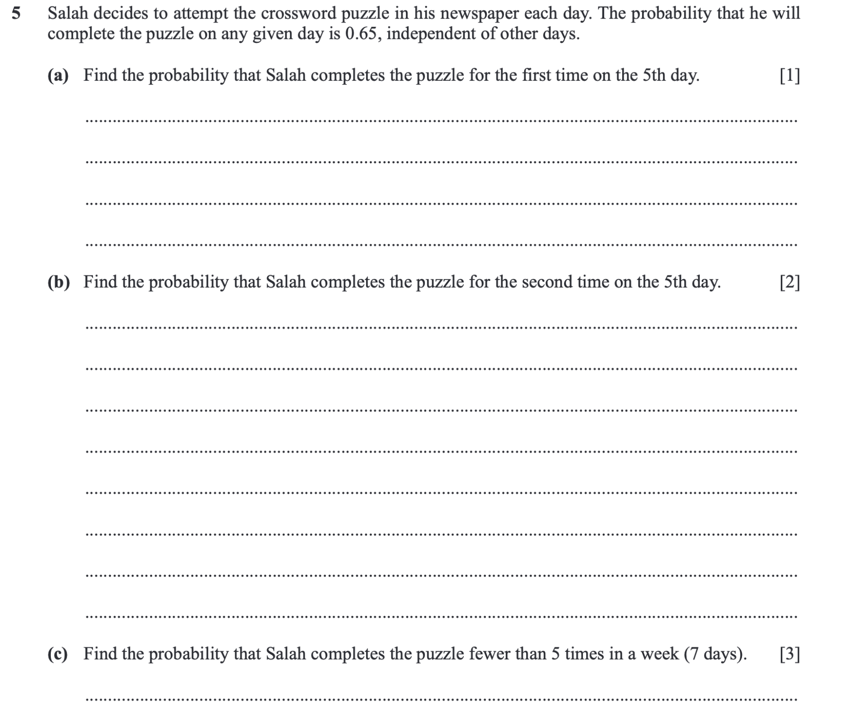

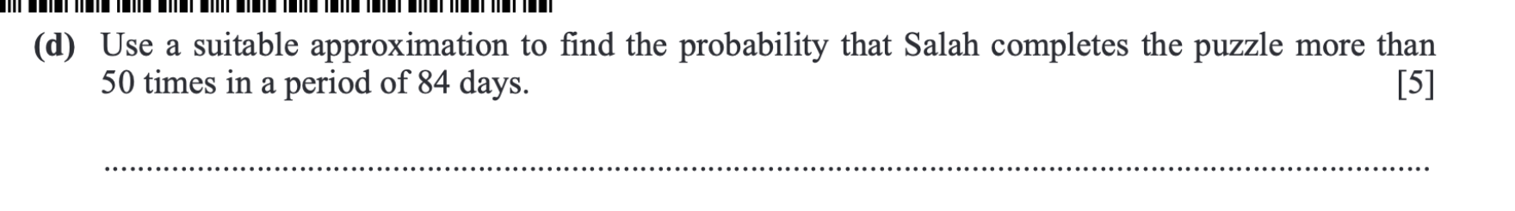

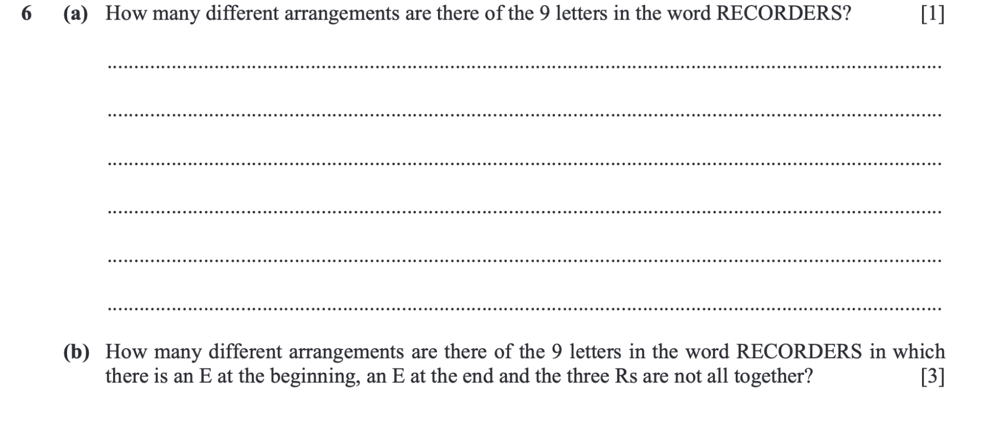

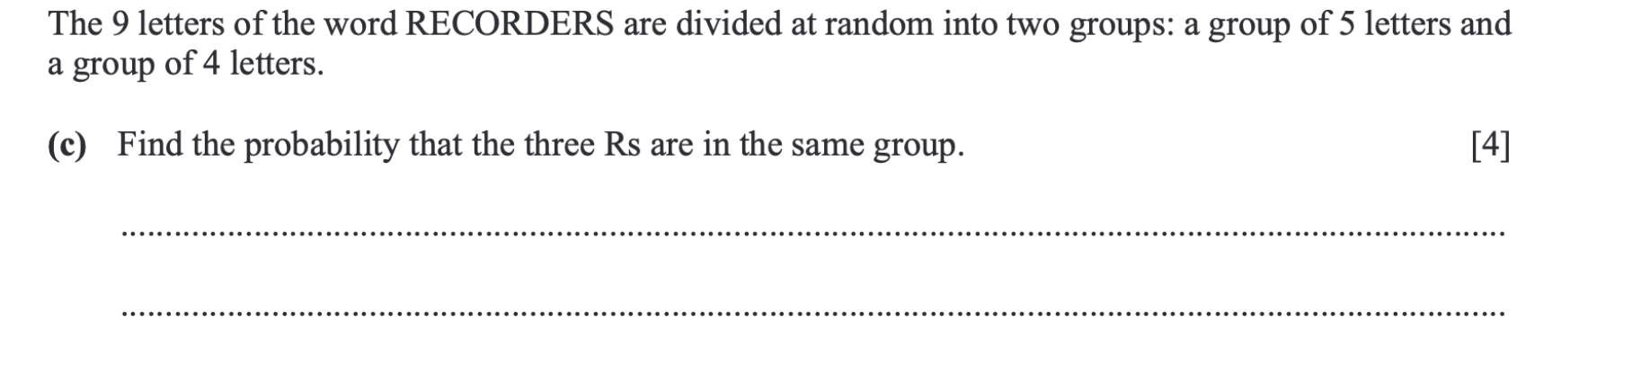

<https://dynamicpapers.com/wp-content/uploads/2015/09/9709_s22_qp_51.pdf>

(Questions 2, 4, 6)

